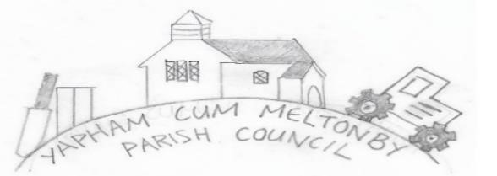

Yapham cum Meltonby Parish Council [www.yaphamcummeltonby.co.uk](http://www.yaphamcummeltonby.co.uk/)  Clerk: Sadie Rothwell-Inch - Tel: 01759 318122 / 07810 260 702 Email:

YCMClerk2@gmail.com

Minutes of the Yapham cum Meltonby **Annual Parish Meeting (APM),** held in

Yapham village hall at **6.30pm** on **Tuesday 13th May 2025**

# MINUTES

1. Cllr Arnold, Cllr Bradley (Chair), Cllr L Hammond, Cllr M Hammond, Clerk and one member of the public. Apologies were received from Reverend Mark Poole.
2. Cllr Bradley welcomed everyone to the meeting
3. The Minutes of the APM for 2024 were adopted as a true record. Proposed by Cllr Arnold and seconded by Cllr Bradley.
4. Report from the YCM Village Hall Committee: No report submitted
5. Report from Reverend Mark Poole for St Martin’s Church, Yapham:

This last year has been very challenging for the PCC and regular worshippers at St Martin’s. For some time we have been aware that the church building is sinking into the ground (mainly clay constitution) and a buttress has been in place for some time. A digital survey of the church building has been carried out and has confirmed that sadly, it is indeed sinking into the ground. It was necessary to spend £17,000 on tis report to ascertain the facts about the integrity of the structure of the building before determining the remedial action required. Estimated repair costs are in the region of £0.5 million. Unfortunately, the PCC does not have the funds, nor does it have capacity to raise the funds to meet this cost or to manage such a huge project. We have been advised that grant funding would be limited and possibly non-existent due to the fact that the church building is adjacent to a fully functional village hall where the very small Church congregation could potentially gather for worship. Following a public consultation meeting in January this year, sadly, a decision was made in conjunction with the Diocese of York that the process for closing the church building should commence. The graveyard will remain open, however. It is not yet known what will happen to the church building, but it is hoped that the site will be commemorated and remembered as a place of significance where folks have gathered to worship God for hundreds of years. Our congregation has grown slightly and sometimes there can be as many as 15 people gathered on a Sunday. It is our hope that there will still be a ‘Church’ (a body of worshipping people) in Yapham for many years to come as we explore an alternative venue.

**Rev’d Mark Poole, Priest-in-Charge and Parish Councillor.**

1. Questions from residents: None present

Meeting Closed at 6:34pm