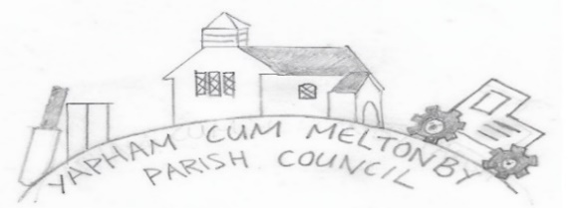

Yapham cum Meltonby Parish Council [www.yaphamcummeltonby.co.uk](http://www.yaphamcummeltonby.co.uk)

Clerk: Sadie Rothwell-Inch - Tel: 01759 318122 / 07810 260 702 Email: YCMClerk2@gmail.com

Dear Councillor,

You are summoned to meeting of Yapham cum Meltonby Parish Council on **Tuesday 11th May 2021 at** **7.30pm. This meeting will be conducted in Yapham village hall.**

If you are unable to attend, please contact me so I can record your apologies. Members of the press or public, wishing to attend, must abide by social distancing guidelines. An agenda for the meeting is shown below.

Yours sincerely,

Sadie Rothwell-Inch, Clerk.

**Meeting 5/21**

**43/21 Welcome and Apologies.**

**44/21 Code of Conduct**

**a) To receive Declarations of Interest from members of the council on matters relating to the agenda.**

**b) To note granting of any dispensations to members of the Council on matters relating to the agenda.**

**45/21 To resolve that the meeting is temporarily suspended to allow for a period of Public Participation.**

**46/21 To adopt the minutes of the meeting held on 13thth April 2020 as a true record.**

**47/21 Matters Arising from previous minutes.**

**48/21 Planning**

1. **To receive** Notification of Decision on App Ref 21/00286/PLF/Erection of single storey extension to existing stables Location: Equestrian Manege Fangfoss Road Yapham Mill YO42 1PB - **Permission granted**
2. **To receive** Notification of Decision on App Ref 21/00179/PLF/Erection of extension to existing garage to form exercise/therapy pool enclosure and ancillary accommodation Location: Yapham Manor Fangfoss Road Yapham Mill YO42 1PB – **Permission granted with conditions.**

**49/21 Finance & Accounts:** The bank balance – £5441.78

To approve the payments: Telephone Box Kit - £154.80 (inc. VAT £25.00 and delivery cost of £10.00)

Clerk salary for May

To receive Precept 2021-22: £3183.00

**50/21 Telephone Box – to resolve project works.**

**51/21 Fast Forward East Riding Community Fund (FFERCF): T**o receive feedback on potential project with village hall outbuildings

**52/21 Local Transport Plan Programme ERYC –** To discuss proposals sent by email.

**53/21To note correspondence*.**

**54/21 Councillors reports.**

**55/21 Date of next meeting.**

*

|  |  |
| --- | --- |
| **Autela** |  |
| 11th April | Yapham Payroll material Handover |
|  |  |
| **ERNLLCA & NALC** |  |
| 20th April | NALC Chief executive's bulletin |
| 27th April | NALC Chief executive's bulletin |
| 3rd May | Disciplinary Training Procedure |
|  |  |
| **ERYC Planning & Development** |  |
| 15th April | Notification of Decision on App Ref 21/00286/PLF |
| 16h April | Notification of Decision on App Ref 21/00179/PLF |
|  |  |
| **ERYC Covid-19 Information** |  |
|  |  |
| **ERYC Legal and Democratic Services** |  |
| 29th April | URGENT - PLEASE READ Remote Meetings |
|  |  |
| **Miscellaneous** |  |
| 27th April | Leeds East Consultation |
| 27t April | Local Transport Plan Programme - ERYC Engineer |
|  |  |
| **Police / Police & crime commissioner** |  |
| 15th April | Newsletter April |