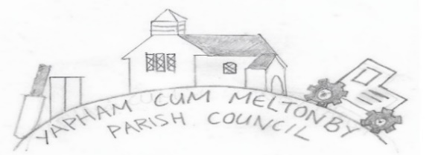

Yapham cum Meltonby Parish Council [www.yaphamcummeltonby.co.uk](http://www.yaphamcummeltonby.co.uk)

Clerk: Sadie Rothwell-Inch - Tel: 01759 318122 / 07810 260 702

Email: YCMClerk2@gmail.com

**ANNUAL MEETING**

Dear Members of YCM Parish Council,

You are hereby summonsed to attend the Yapham cum Meltonby **Annual Meeting of the Parish Council,** taking place in Yapham village hall, at **7.00pm** on **Tuesday 11th May 2021**.

Members of the press or public, wishing to attend, must abide by social distancing guidelines.

Yours sincerely,

S Rothwell-Inch, Clerk.

AGENDA

1. To elect the Yapham cum Meltonby Parish Council Chairman and receive the Chairman’s declaration of acceptance of office.

2. To receive apologies on behalf of absent members.

3. To elect the Vice-Chairman for the forthcoming year and to receive the Vice Chairman’s declaration of acceptance of office.

4. To adopt the minutes of Yapham cum Meltonby Annual Meeting from Tuesday 14th May 2019.

5. To elect Members to represent the PC on the following:

• Personnel Committee

• Neighbourhood Watch

6. To elect two councillors to represent this council at ERNLLCA district committee meetings.

7. Chairman’s Report.

8. To receive the Yapham cum Meltonby Parish Council Summary of Receipts and Payments Accounts for the year ending 31st March 2021.

9. To note the Internal Auditors report.

10. To discuss and sign the External Auditor's Certificate of Exemption 2020/21.

11. To discuss, complete and sign the Annual Governance Statement 2020/2021

12. To discuss and sign the Accounting Statements 2020/2021

13.  **To approve financial arrangements for the coming year:**

a) To approve the Financial Standing Orders

b) To appoint an internal auditor

14. Provisional date for the next Annual Meeting.