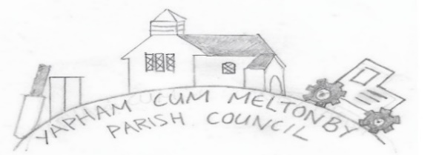

Yapham cum Meltonby Parish Council [www.yaphamcummeltonby.co.uk](http://www.yaphamcummeltonby.co.uk)

Clerk: Sadie Rothwell-Inch - Tel: 01759 318122 / 07810 260 702 Email: YCMClerk2@gmail.com

Dear Members of the Parish of Yapham cum Meltonby,

You are hereby invited to attend your Yapham cu Meltonby **Annual Parish Meeting (APM),** taking place in Yapham village hall at **6.45pm** on **Tuesday 11th May 2021**.

Yours sincerely,

P Bradley, Chair of the Parish Council.

AGENDA

1. Present
2. Welcome from the Chair
3. To confirm no Minutes of the APM for 2021 due to the Covid-19 pandemic.
4. To receive a report from the YCM Village Hall Committee.
5. To receive a report from St Martin’s Church, Yapham.
6. To accept any questions from residents.