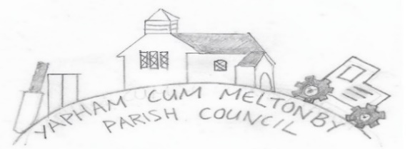

Yapham cum Meltonby Parish Council [www.yaphamcummeltonby.co.uk](http://www.yaphamcummeltonby.co.uk)

Clerk: Sadie Rothwell-Inch - Tel: 01759 318122 / 07810 260 702 Email: YCMClerk2@gmail.com

Dear Councillor,

A meeting of Yapham cum Meltonby Parish Council will be held on **Tuesday 8th June 2021 at** **7.30pm.**

**In Yapham Village Hall.**

If you are unable to attend, please contact me so that I can record your apologies. Members of the public are welcome to attend the meeting and may address the council during the Public Participation period. An agenda for the meeting is shown below.

Yours sincerely,

Sadie Rothwell-Inch, Clerk.

**Meeting 6/21**

**56/21 Welcome and Apologies.**

**57/21 Code of Conduct**

**a) To receive Declarations of Interest from members of the council on matters relating to the agenda.**

**b) To note granting of any dispensations to members of the Council on matters relating to the agenda.**

**58/21 To resolve that the meeting is temporarily suspended to allow for a period of Public Participation.**

**59/21. To adopt the minutes of the Annual Meeting of the Parish Council held 11th May 2021**

**59A/21 To adopt the minutes of the meeting held 11th May 2021**

**60/21 Matters Arising.**

**61/21 Planning – To consider:** 21/01468/PLF Yapham Holds Farmhouse Feoffee Lane YO42 1PF/ Erection of a washing and WC facility for the pod site and domestic garage / garden store following demolition of existing out building.

**62/21 Finance & Accounts:** The bank balance – £5,541.78

To approve the payments:

1. Clerk’s salary for June 2021
2. Emma Fletcher – Internal Audit 2021: £168.00

**63/21 Litter-Pick: To resolve arrangements for 2021 parish pick.**

**64/21 Parish Project and Grant Application – To receive any updates and consider the next stage.**

**65/21 Neighbourhood Watch – To receive any updates**

**66/21 To note correspondence*.**

**67/21 Councillors reports.**

**68/21 Date of next meeting.**

**\***

|  |  |
| --- | --- |
| **ERNLLCA & NALC** |  |
| 20th April | NALC Chief executive's bulletin |
| 27th April | NALC Chief executive's bulletin |
| 3rd May | Disciplinary Training Procedure |
|  |  |
| **ERYC Planning & Development** |  |
| May 24th | Consultation 21/01468/PLF Yapham Holds Farmhouse |
| May 28th | Draft Local Plan Update Consultation |
|  |  |
|  |  |
| **ERYC Legal and Democratic Services** |  |
| May 18th | Letter to Town & Parish Councils |
| Jun 1st | Update on Meetings / Request for Clerk |
|  |  |
| **Miscellaneous** |  |
| Jun 1st | My Job Coach poster |
|  |  |
| **Police / Police & crime commissioner** |  |
| May 19th | Newsletter May |
| May 20th | Police Surgery dates at Mkt Weighton |
| May 21st | OPCC 'Take 5' , 'Say No To Fraud Campaign' Launched 20th May 2021 |
|  |  |