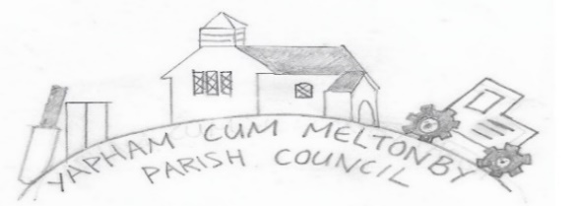

Yapham cum Meltonby Parish Council [www.yaphamcummeltonby.co.uk](http://www.yaphamcummeltonby.co.uk)

Clerk: Sadie Rothwell-Inch – Tel: 07810 260 702 Email: YCMClerk2@gmail.com

Dear Councillor,

A meeting of Yapham cum Meltonby Parish Council will be held on **Tuesday 6th July 2021 at** **7.30pm.**

**In Yapham Village Hall.** If you are unable to attend, please contact me so that I can record your apologies. Members of the public are welcome to attend the meeting and may address the council during the Public Participation period. An agenda for the meeting is shown below.

Yours sincerely,

Sadie Rothwell-Inch, Clerk.

**Meeting 7/21**

**69/21 Welcome and Apologies.**

**70/21 Code of Conduct**

**a) To receive Declarations of Interest from members of the council on matters relating to the agenda.**

**b) To note granting of any dispensations to members of the Council on matters relating to the agenda.**

**71/21 To resolve that the meeting is temporarily suspended to allow for a period of Public Participation.**

**72/21. To adopt the minutes of the meeting held 8th June 2021**

**73/21 Matters Arising**

**74/21 Planning:**

1. **Notice of Decision:** 21/00341/PLF Erection of extension to general purpose agricultural buildings to use for livestock and straw/feed storage: **Granted with conditions.**
2. **Planning for:** Treveen House **-** Application to change an existing licence as follows: To keep an extra two goods vehicles and four trailers at the operating centre / Treveen House, Meltonby, YO42 1PN.

**75/21 Finance & Accounts:** The bank balance – £5,373.78

To approve the payments:

1. Clerk’s salary for July 2021

**76/21 Yapham Mill - Proposed 40mph speed limit**

**77/21 Parish Project and Grant Application – To receive any updates and consider the next stage.**

**78/21 To note correspondence*.**

**79/21 Councillors reports.**

**80/21 Date of next meeting.**

**\***

|  |  |
| --- | --- |
| **Miscellaneous** |  |
| June 9th | My Job Coach poster |
| June 9th | The East Riding of Yorkshire Community Tree Planting Fund |
| June 21st | ERYC Health and Wellbeing Team's Newsletter |
|  |  |
| **Police / Crime commissioner** |  |
| June 9th | June Newsletter |
| June 18th | Police and Crime Plan consultation |
|  |  |
| Rural News |  |
| June 22nd | The Rural Bulletin - 22 June 2021 |
|  |  |