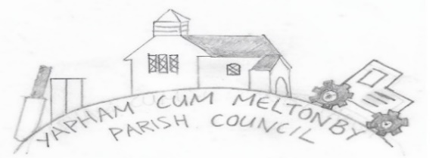

Yapham cum Meltonby Parish Council [www.yaphamcummeltonby.co.uk](http://www.yaphamcummeltonby.co.uk)

Clerk: Sadie Rothwell-Inch – Tel: 07810 260 702 Email: YCMClerk2@gmail.com

Dear Councillor,

A meeting of Yapham cum Meltonby Parish Council will be held on **Tuesday 10th August 2021 at** **7.30pm.**

**In Yapham Village Hall.** If you are unable to attend, please contact me so that I can record your apologies. Members of the public are welcome to attend the meeting and may address the council during the Public Participation period. An agenda for the meeting is shown below.

Yours sincerely,

Sadie Rothwell-Inch, Clerk.

**Meeting 8/21**

**81/21 Welcome and Apologies.**

**82/21 Code of Conduct**

**a) To receive Declarations of Interest from members of the council on matters relating to the agenda.**

**b) To note granting of any dispensations to members of the Council on matters relating to the agenda.**

**83/21 To resolve that the meeting is temporarily suspended to allow for a period of Public Participation.**

**84/21. To adopt the minutes of the meeting held 6th July 2021**

**85/21 Matters Arising**

**86/21 Planning:**

1. **To receive update and additional documentation from the Office of the Traffic Commissioner for:** Chemplus Ltd **-** Application to change an existing licence as follows: To keep an extra two goods vehicles and four trailers at the operating centre / Treveen House, Meltonby, YO42 1PN.
2. **To receive notification of decision on:** App Ref21/01468/PLF / Erection of a washing and WC facility for the pod site and domestic garage/garden store following demolition of existing out building / Yapham Holds Farmhouse Feoffee Lane Yapham YO42 1PF Applicant: Mr & Mrs N Knowles: **Permission granted.**

**87/21 Finance & Accounts:** Bank balance – £5,209.38 (no clerk salary payment deducted due to HMRC issues)

To approve the payments:

1. Village Hall Hire: Invoice 1/21 May & June - £40.00
2. Clerk’s salary for August 2021

**88/21 Parish Project and Grant Application – To receive any updates and consider the next stage.**

**89/21 Cricket Club – To consider their request for a defibrillator**

**90/21 The Queens Jubilee – To discuss funding and ideas to commemorate**

**91/21 PC Laptop – To discuss action to resolve its slow response time and general performance**

**92/21 To note correspondence*.**

**93/21 Councillors reports.**

**94/21 Date of next meeting.**

**\***

|  |  |
| --- | --- |
| **ERYC Planning & Development** |  |
| July 2nd | Meeting Invitation: Town and Parish Council Online Consultation Meetings |
| July 1st | Notification of Decision on App Ref 21/01468/PLF |
| July 30th | Town and Parish Council Planning Liaison Meetings Notes & Presentation |
|  |  |
|  |  |
| **Miscellaneous** |  |
| June 8th (found in SPAM) | The Queen's Jubilee |
| Aug 2nd | OB2017074 / 1262790 CHEMPLUS LTD - Traffic Commissioner |
|  |  |
|  |  |
| **Police / Crime commissioner** |  |
| July 21st | Newsletter |
| Aug 3rd | Newsletter |