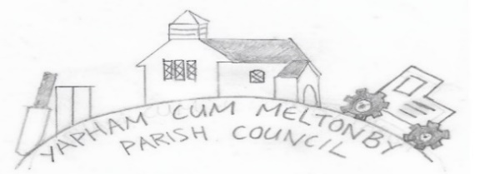

Yapham cum Meltonby Parish Council [www.yaphamcummeltonby.co.uk](http://www.yaphamcummeltonby.co.uk)

Clerk: Sadie Rothwell-Inch - Tel: 01759 318122 / 07810 260 702

Email: YCMClerk2@gmail.com

Minutes of the Annual Parish (APM) meeting of Yapham cum Meltonby Parish Council

on 14th May 2019 in Yapham Village hall at 7.00pm

1. Present: Cllr Arnold, Cllr Bradley (chair), Cllr Gray, Cllr Hammond, Cllr Moverley, Cllr Newman, Clerk.

Apologies from Cllr Jefferson-Hallett.

1. Cllr Bradley welcomed everyone to the meeting.
2. It was agreed there was no APM during the 2020 Covid-19 lockdown.
3. Cllr Arnold delivered:

Reverend J Hardy was unable to attend the meeting so sent the following report via email:

*St. Martins’ Church Yapham serves the communities of Yapham, Yapham Mill and Meltonby. It is part of the Barmby Moor Group of Churches, which also includes the parishes of Allerthorpe, Barmby Moor, Fangfoss and Thornton with Melbourne, which reside in the Diocese of York. It is served by a vicar currently myself, who lives in the*

*Vicarage at Barmby Moor. St. Martin’s Churchwarden is Dr Elaine Stubbings. Prior to the Coronavirus Pandemic the Church was open every day for visitors and those wishing a quiet space for reflection to use. Currently it is open three days a week Saturdays, Sundays, and Mondays under Covid secure guidelines. Prior to the Pandemic it held services on the first and fourth Sundays of the month at 10.45am. During the first two lockdowns worship was not allowed to take place in any place of worship, in this last lockdown, services were held once a month and have now returned to twice a month. Covid safe restrictions are in place at these services and all other services which take place in the church building. We have done our best in these challenging times to remain open and be a resource to the communities we serve. St. Martin’s Church needs some major repairs and restoration on the building emanating from poor foundations, subsidence, and structural movement, this has been identified because of investigation work which has taken place. To do the minimum amount of repair work would cost in the region of £125 000. This is a substantial amount of money for a small community and a small congregation to find. St. Martin’s is fortunate in being one of only six Churches in the Diocese of York to gain the support of the Centre for Contemporary Christianity and Culture based at York University, who will be helping the PCC to move a project forward which has the potential to not only repair the building but to enable it to be a community facility for the parish and wider community. It will be known as an ‘Oasis’. Church where people can come and find peace and stillness in the building or indeed as in the first two lockdowns in the churchyard which is a wonderful community resource. We will look to make the access to the church accessible and the budling itself accessible and for it to be equipped with a small kitchenette and toilet, this revised and enhanced project will cost in the region of £200 000. As this project develops, we would like to inform the Parish Council about what is happening and hope that you might be able to support what we are doing as we enhance the community facilities and enable the church plant to be a space which can be accessed by anyone.*

*Revd. Jan Hardy 150521*

Meeting closed at 7.55pm