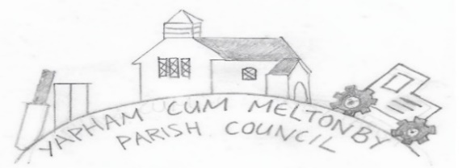

Yapham cum Meltonby Parish Council [www.yaphamcummeltonby.co.uk](http://www.yaphamcummeltonby.co.uk)

Clerk: Sadie Rothwell-Inch - Tel: 01759 318122 / 07810 260 702 Email: YCMClerk2@gmail.com

Minutes of Yapham cum Meltonby Parish Council Meeting

on **Tuesday 8th June 2021** in Yapham Village Hall

**Meeting 6/21**

56/21Present**:** Cllr Arnold, Cllr Bradley (in the chair), Cllr Gray, Cllr Hammond, Cllr Moverley, Cllr Newman, Clerk. Apologies from Cllr Jefferson-Hallett. Cllr Bradley welcomed everyone to the meeting.

**57/21 Code of Conduct**

a) Cllr Hammond declared an abstention from comment and vote on planning due to his ERYC Committee role.

b) There were no requests for granting of any dispensations

**58/21** No members of the public were present.

**59/21. The minutes** of the Annual Meeting of the Parish Council held 11th May 2021 were adopted as a true record. Prop Cllr Gray, seconded Cllr Moverley.

**59A/21 The minutes** of the meeting held 11th May2021 were adopted as a true record. Prop Cllr Gray, seconded Cllr Moverley.

**60/21 Matters Arising:** Cllr Hammond would like to now purchase the telephone box kit. ACTION (Clerk).

**61/21 Planning – Application** 21/01468/PLF Yapham Holds Farmhouse Feoffee Lane YO42 1PF/ Erection of a washing and WC facility for the pod site and domestic garage / garden store following demolition of existing out building.: **Agreed:** Council supports the sensitive development and local business growth.

**62/21 Finance & Accounts:** The bank balance – £5,541.78

The following payments were approved. Prop Cllr Gray, seconded Cllr Hammond.

1. Clerk’s salary for June 2021
2. Emma Fletcher – Internal Audit 2021: £168.00

**63/21 Parish Litter-Pick:** Arranged for Sunday 4th July at 2pm**.** ACTION: Leaflet production and distribution (LH) Parish email (PA) and contact ERYC for equipment (Clerk).

**64/21 Parish Project and Grant Application: Resolved –** Apply for £500.00 for a Parish Wildlife Initiative. Promote wildlife care and conservation with a community day of activities including building such items as bird boxes, hedgehog hides, insect hotels and any other reasonable suggestions. Dates and specifics to be arranged at the July meeting. ACTION: Apply for grant (LH, Clerk)

**65/21 Neighbourhood Watch:** Cllr Moverley receives regular updates and communication but has nothing specific to report currently.

**66/21 Correspondence:** Noted.

**67/21 Councillors reports:** Updates covered in agenda items.

**68/21 Date of next meeting:** Tuesday 13th July

Meeting closed at 8.15pm