Yapham cum Meltonby Parish Council

[www.yaphamcummeltonby.co.uk](http://www.yaphamcummeltonby.co.uk)

Clerk : Mrs Jo Green, 29 Barmby Road, Pocklington, York YO42 2DL Tel.01759 301386

Dear Councillor

A meeting of Yapham cum Meltonby Parish Council will be held on **Tuesday 10th May 2016** in the **Village Hall, Yapham at 7.30pm**. You are summoned to attend, if you are unable to attend, would you please contact me in order that I can record your apologies.

Members of the public are welcome to attend the meeting and may address the council during the Public Participation period. An agenda for the meeting is shown below.

Yours sincerely,

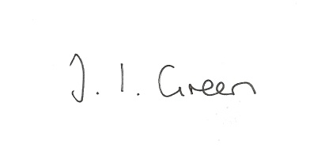

Joanna Green, clerk of the council. 5/5/15

AGENDA

**40/16 Welcome and Apologies**

**41/16 To elect officers:**

Chairman

Vice- Chairman

Representatives to other bodies

**42/16 To approve the Annual Governance Statement for 2015/16**

**43/16 to approve the accounts for 2015/16**

**44/16 to approve financial arrangements for the coming year :**

To approve the Financial Standing Orders

To appoint an internal auditor

To appoint bank signatories.

**45/16 To receive Declarations of Interest**.

**46/16 To adopt the minutes of the meeting held on 12th April 2016 as a true record**

**47/16 To receive the clerk's report on matters being progressed from previous meetings.**

Trees at the Gravel Pit Field

Asset Register

**48/16 Planning**

To consider whether any further action should be taken following the planning appeal

regarding the application for retention of a log cabin at Eastfield, Feoffee Common Lane.

**49/16 Accounts**

The bank balance at £3925.34

To approve the payments below:

Clerk's salary April £129.97

**50/16 Correspondence**

ERNLLCA Newsletter April

ERYC re Antisocial Behaviour statistics

ERYC re Tesco Bags of Help Funding

ERYC re Skipton Building Society Grassroots funding

East Yorks. Motor Services re diversion of bus service 747

Clerks & Councils Direct

**51/16 Councillors reports**

**52/16 Date of next meeting**