Yapham cum Meltonby Parish Council

[www.yaphamcummeltonby.co.uk](http://www.yaphamcummeltonby.co.uk)

Clerk : Mrs Jo Green, 29 Barmby Road, Pocklington, York YO42 2DL Tel.01759 301386

Dear Councillor

A meeting of Yapham cum Meltonby Parish Council will be held on **Tuesday 11th October 2016** in the **Village Hall, Yapham at 7.30pm**. You are summoned to attend, if you are unable to attend, would you please contact me in order that I can record your apologies.

Members of the public are welcome to attend the meeting and may address the council during the Public Participation period.

Yours sincerely,

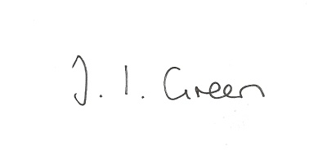

Joanna Green, clerk of the council 6/10/16

AGENDA

**Welcome**

**Public Session**

**95/16 Apologies**

**96/16 To receive Declarations of Interest**.

**97/16 To adopt the minutes of the meeting held on 13th September 2016 as a true record**

**98/16 To receive the clerk's report on matters being progressed from previous meetings.**

New road name

**99/16Planning**

Clerk to report on planning enforcement issues.

**100/16 Accounts**

The bank balance £ 3803.64

To approve the payments below:

Clerk's salary and allowance August £134.01

Autela Payroll Services £27.95

**92/16 Correspondence**

ERNLLCA September newsletter

Humberside Police Bulletin October

ERYC re Hull City of Culture

**93/16 Councillors reports**

**94/16 Date of next meeting**