Yapham cum Meltonby Parish Council

[www.yaphamcummeltonby.co.uk](http://www.yaphamcummeltonby.co.uk)

Clerk : Mrs Jo Green, 29 Barmby Road, Pocklington, York YO42 2DL Tel.01759 301386

Dear Councillor

A meeting of Yapham cum Meltonby Parish Council will be held on **Tuesday 12th April 2016** in the **Village Hall, Yapham at 7.30pm**. You are summoned to attend, if you are unable to attend, please contact me in order that I can record your apologies.

Members of the public are welcome to attend the meeting and may address the council during the Public Participation period. An agenda for the meeting is shown below.

Yours sincerely,

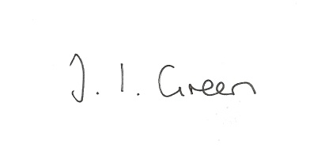Joanna Green, clerk of the council. 7/4/2016

AGENDA

**Welcome**

**Public Session**

**29/16 Apologies.**

**30/16 To receive Declarations of Interest.**

**31/16 To adopt the minutes of meetings held on 8th March 2016 as a true record**

**32/16 To receive the clerk's report on matters being progressed from previous meetings.**

Planning enforcement

**33/16 To receive a report on the site visit to the Gravel Pit Field**

**34/16 To review and update the council's asset register**

**35/16 Accounts**

Bank balance £1739.11

To approve the payments below:

Clerk's salary- March £113.57

HMRC £49.20

Autela payroll services- Jan-Mar £21.75

ERNLLCA subscription £227.08

Yapham Parish Hall Fund £40.00

**36/16 Correspondence**

Yapham Cricket Club 2016 fixtures

ERNLLCA newsletter

ERYC re Community Infrastructure levy

Social Action Partners Conference

ERYC Connecting Communities Grant Fund

ERYC - Brownfield sites

ERYC - Public Spaces Protection Orders consultation

ERYC - Parish Council Planning Liaison meetings 2016

Ward Councillors -Parish Council Liaison meeting 28 April

ERYC- Safe & Sound grant

Humberside Police - April newsletter

**37/16 Councillors reports**

**38/16 Date of next meeting**