Yapham cum Meltonby Parish Council

[www.yaphamcummeltonby.co.uk](http://www.yaphamcummeltonby.co.uk)

Clerk : Mrs Jo Green, 29 Barmby Road, Pocklington, York YO42 2DL Tel.01759 301386

Dear Councillor

A meeting of Yapham cum Meltonby Parish Council will be held on **Tuesday 12th July 2016** in the **Village Hall, Yapham at 7.30pm**. You are summoned to attend, if you are unable to attend, would you please contact me in order that I can record your apologies.

Members of the public are welcome to attend the meeting and may address the council during the Public Participation period.

Yours sincerely,

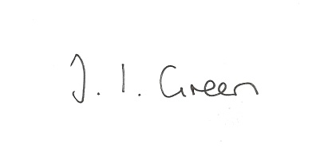

Joanna Green, clerk of the council 7/7/15

AGENDA

**Welcome**

**Public Session**

**64/16 Apologies**

**65/16 To receive Declarations of Interest**.

**66/16 To adopt the minutes of the meeting held on 14th June 2016 as a true record**

**67/16 To receive the clerk's report on matters being progressed from previous meetings.**

Public Transport Consultation

GP services

Gravel Pit field land registration

Broadband

**68/16 Planning**

**16/01847/PLF** Erection of 325 dwellings, landscaping and associated works including provision of highway and drainage infrastructure and open space [AMENDED PLANS] at Land North Of Westfield Road, Yapham Road, Pocklington, East Riding Of Yorkshire, for Bellway Homes (Yorkshire) Ltd -

Application type: Strategic - Full Planning Permission

**16/02066/PLF** Proposal: Erection of stable block following demolition of existing

Location: The Paddock Fangfoss Road Yapham Mill East Riding Of Yorkshire YO42 1PB

Applicant: Mr R C Bond Application type: Full Planning Permission

**16/01847/PLF** Proposal: Erection of a dwelling with detached garage

Location: Land East Of Embege Feoffee Lane Yapham East Riding Of Yorkshire YO421PF

Applicant: Mr Paul Wild Application type: Full Planning Permission

**69/16 Accounts**

The bank balance £ 3796.48

To approve the payments below:

Clerk's salary June £129.97

**70/16 Correspondence**

Skipton Building Society re Grassroots Giving

East Riding Clinical Commissioning Group re AGM

Bainton Parish Council Chairman re Fracking speaker

Paul Lai re Petition to Help reduce Suicides

Humberside Police July bulletin

ERNLLCA Newsletter June

Clerks & Councils Direct

ERYC Funding Times

**71/16 Councillors reports**

**72/16 Date of next meeting**