**Yapham cum Meltonby Parish Council**

[www.yaphamcummeltonby.co.uk](http://www.yaphamcummeltonby.co.uk)

Clerk : Mrs Jo Green, 29 Barmby Road, Pocklington, York YO42 2DL Tel.01759 301386

Dear Councillor

A meeting of Yapham cum Meltonby Parish Council will be held on **Tuesday 13th December 2016** in the **Village Hall, Yapham at 7.30pm**. You are summoned to attend, if you are unable to attend, would you please contact me in order that I can record your apologies.

Members of the public are welcome to attend the meeting and may address the council during the Public Participation period.

Yours sincerely,

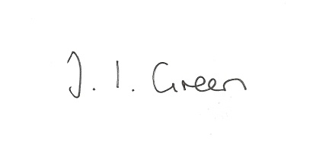

Joanna Green, clerk of the council 8/12/16

AGENDA

**113/16 Welcome & Apologies**

**114/16 To receive Declarations of Interest**.

**115/16 To resolve that the meeting is temporarily suspended to allow for a period of Public Participation**

**116/16 To adopt the minutes of the meeting held on 8th November 2016 as a true record**

**117/16 To receive the clerk's report on matters being progressed from previous meetings.**

Police response to incidents at Bishop Wilton

Planning issues:

Stable Manager's dwelling

Alder Lodge

**118/16 To consider quotations for insurance for 2017**

**119/16 Tour de Yorkshire**

**120/16 Accounts**

The bank balance £ 3447.67

To approve the payments below:

Clerk's salary and allowance November £134.01

Society of Local Council Clerks subscription £27.47

**121/16 to consider the budget for 2017/18 and set the precept**

**122/16 Correspondence**

HWRCC - Community Led Housing workshop

Dove House Hospice - Christmas Appeal

ERYC - Co-op Local Community Fund

ERYC - Antisocial Behaviour report

ERYC - meeting re final proposals for bus services 5 December at Beverley

Western Parishes Liaison Group - date of next meeting 26 January at Shiptonthorpe

Humberside Police Dec newsletter

ERYC - chairman's awards

NHS- Urgent Care Consultation

Stones4 homes - prices for salt

Parish Magazine

**123/16 Councillors reports**

**124/16 Date of next meeting**