Yapham cum Meltonby Parish Council

[www.yaphamcummeltonby.co.uk](http://www.yaphamcummeltonby.co.uk)

Clerk : Mrs Jo Green, 29 Barmby Road, Pocklington, York YO42 2DL Tel.01759 301386

Dear Councillor

A meeting of Yapham cum Meltonby Parish Council will be held on **Tuesday 13th September 2016** in the **Village Hall, Yapham at 7.30pm**. You are summoned to attend, if you are unable to attend, would you please contact me in order that I can record your apologies.

Members of the public are welcome to attend the meeting and may address the council during the Public Participation period.

Yours sincerely,

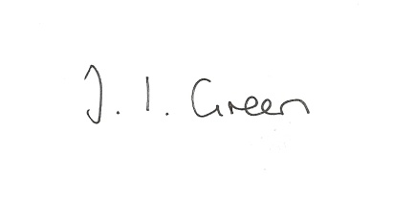

Joanna Green, clerk of the council 8/9/16

AGENDA

**Welcome**

**Public Session**

**83/16 Apologies**

**84/16 To receive Declarations of Interest**.

**85/16 To consider the Co-option of a new councillor**

**86/16 To adopt the minutes of the meeting held on 9th August 2016 as a true record**

**87/16 To receive the clerk's report on matters being progressed from previous meetings.**

Bus consultation

Audit

Transparency Code Funding

**88/16 Street naming :** to consider the request from ERYC for a name for the road from Yapham Grange, Yapham Mill to Keldspring Lane

**89/16Planning**

**To receive notice of:**

refusal of16/01847/PLF

Proposal: Erection of a dwelling with detached garage

Location: Land East Of Embege Feoffee Lane Yapham East Riding Of Yorkshire YO42 1PF

Applicant: Mr Paul Wild

approval of 16/02066/PLF

Proposal: Erection of stable block following demolition of existing

Location: The Paddock Fangfoss Road Yapham Mill East Riding Of Yorkshire

YO42 1PB

Applicant: Mr R C Bond

Clerk to report on planning enforcement issues.

**90/16 To consider a request for a defibrillator in Yapham**

**91/16 Accounts**

The bank balance £ 4429.65

To approve the payments below:

Clerk's salary and allowance August £134.01

**92/16 Correspondence**

ERYC re A1079 resurfacing

ERYC re Public Space Protection Orders

Zurich Insurance re increase in Insurance Premium tax

ERNLLCA August newsletter

Humberside Police Bulletin

Clerks & Councils Direct

**93/16 Councillors reports**

**94/16 Date of next meeting**