Yapham cum Meltonby Parish Council

[www.yaphamcummeltonby.co.uk](http://www.yaphamcummeltonby.co.uk)

Clerk : Mrs Jo Green, 29 Barmby Road, Pocklington, York YO42 2DL Tel.01759 301386

Dear Councillor

A meeting of Yapham cum Meltonby Parish Council will be held on **Tuesday 14th June 2016** in the **Village Hall, Yapham at 7.30pm**. You are summoned to attend, if you are unable to attend, would you please contact me in order that I can record your apologies.

Members of the public are welcome to attend the meeting and may address the council during the Public Participation period.

Yours sincerely,

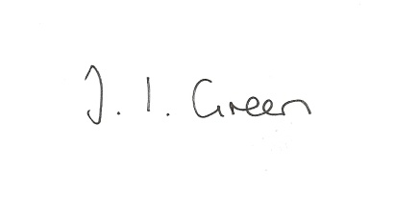

Joanna Green, clerk of the council. 8/6/15

AGENDA

**Welcome**

**Public Session**

**53/16 Apologies**

**54/16 To receive Declarations of Interest**.

**55/16 To adopt the minutes of the meeting held on 10th May 2016 as a true record**

**56/16 To receive the clerk's report on matters being progressed from previous meetings.**

Feral Cats

Public Transport Champion reporting

Planning appeal, Eastfield, Feoffee Common Lane.

**57/16 General Practitioner and associated medical services:** To assess what action the Parish Council might take regarding parishioners' concerns about the level of services in this area.

**58/16 Transparency Code** To receive a report from the clerk regarding the council's responsibilities under the code and to consider applying for funding to assist in complying with the new code.

**59/16 To consider the recent salary award to clerks**.

**60/16 Accounts**

The bank balance £3795.37

To approve the payments below:

Clerk's salary May £129.97

**61/16 Correspondence**

ERYC consultation regarding Joint Minerals Plan ERYC re Overview and Scrutiny Committee meetings

Beverley Folk Festival ERYC re council tax discounts

ERYC consultation about library services. Humberside Police June bulletin

ERYC re Big Energy Saving Network grants ERNLLCA Newsletter May

Yapham Cricket Club re opening event

**62/16 Councillors reports**

**63/16 Date of next meeting**