Yapham cum Meltonby Parish Council

[www.yaphamcummeltonby.co.uk](http://www.yaphamcummeltonby.co.uk)

Clerk : Mrs Jo Green, 29 Barmby Road, Pocklington, York YO42 2DL Tel.01759 301386

Dear Councillor

A meeting of Yapham cum Meltonby Parish Council will be held on **Tuesday 8th March 2016** in the **Village Hall, Yapham at 7.30pm**. You are summoned to attend, if you are unable to attend, please contact me in order that I can record your apologies.

Members of the public are welcome to attend the meeting and may address the council during the Public Participation period. An agenda for the meeting is shown below.

Yours sincerely,

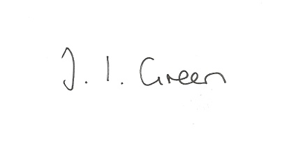Joanna Green, clerk of the council. 3/3/2016

AGENDA

**Welcome**

**Public Session**

**19/16 Apologies.**

**20/16 To receive Declarations of Interest.**

**21/16 To adopt the minutes of meetings held on 9th February 2016 as a true record**

**22/16 To receive the clerk's report on matters being progressed from previous meetings.**

Neighbourhood Watch

Dog Fouling in Yapham

Website

Pension auto-enrolment

**23/16 Planning**

**To resolve to support or otherwise the application below:**

16/00107/STPLF

Proposal: Erection of 325 dwellings, landscaping and associated works including provision

of highway and drainage infrastructure and open space

Location: Land North Of Westfield Road Yapham Road Pocklington East Riding Of

Yorkshire

Applicant: Bellway Homes (Yorkshire) Ltd

Application type: Strategic - Full Planning Permission

**24/16 To review the Gravel Pit Field Tenancy Agreement** and to consider whether or not any amendments are necessary regarding the maintenance of the hedges.

**25/16 Accounts**

Bank balance £1898.45

To approve the payments below:

Clerk's salary £113.57

Clerk's expenses £45.77

**26/16 Correspondence**

Brad Webster re retirement from ERYC

Marie Curie daffodil appeal 2016

APEM Aquatic Scientists re Foulness Water Courses

Tower Mint Ltd re 90th birthday commemorative medals

ERYC Road Closure notice Pocklington to Bolton from 22 April

Humberside Police Bulletin - March

ERNLLCA newsletter- Feb

Frack Free east Yorkshire re meetings with gas companies

ERNLLCA re meetings with gas companies

Clerks and Councils Direct

**27/16 Councillors reports**

**28/16 Date of next meeting**