Yapham cum Meltonby Parish Council

[www.yaphamcummeltonby.co.uk](http://www.yaphamcummeltonby.co.uk)

Clerk : Mrs Jo Green, 29 Barmby Road, Pocklington, York YO42 2DL Tel.01759 301386

Dear Councillor

A meeting of Yapham cum Meltonby Parish Council will be held on **Tuesday 8th November 2016** in the **Village Hall, Yapham at 7.30pm**. You are summoned to attend, if you are unable to attend, would you please contact me in order that I can record your apologies.

Members of the public are welcome to attend the meeting and may address the council during the Public Participation period.

Yours sincerely,

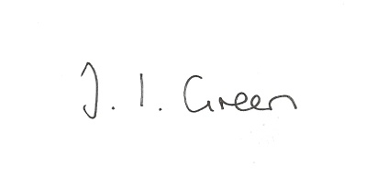

Joanna Green, clerk of the council 3/11/16

AGENDA

**Welcome**

**Public Session**

**104/16 Apologies**

**105/16 To receive Declarations of Interest**.

**106/16 To adopt the minutes of the meeting held on 11th October 2016 as a true record**

**107/16 To receive the clerk's report on matters being progressed from previous meetings.**

Police response to incidents at Bishop Wilton

Safe Neighbourhood event

**108/16 Accounts**

The bank balance £ 3803.64

To approve the payments below:

Clerk's salary and allowance August £134.01

**109/16 Budgeting for 2016/17** To discuss plans for 2016/17 in advance of setting the precept for next year.

**110/16 Correspondence**

ERYC - letter regarding problems with the bus services

NHS - Urgent Care consultation

ERYC - Rough Sleepers Estimate 16 Nov 16 Between 2.00am and 6.00am

Humberside Police Nov newsletter

ERNLLCA Oct Newsletter

ERYC - budget consultation

ERYC - EPIC awards

ERYC - Landscape Assessment consultation

HWRCC - Invitation to join

Clerks & Councils Direct

**111/16 Councillors reports**

**112/16 Date of next meeting**