Yapham cum Meltonby Parish Council

[www.yaphamcummeltonby.co.uk](http://www.yaphamcummeltonby.co.uk)

Clerk : Mrs Jo Green, 29 Barmby Road, Pocklington, York YO42 2DL Tel.01759 301386

Dear Councillor

A meeting of Yapham cum Meltonby Parish Council will be held on **Tuesday 9th August 2016** in the **Village Hall, Yapham at 7.30pm**. You are summoned to attend, if you are unable to attend, would you please contact me in order that I can record your apologies.

Members of the public are welcome to attend the meeting and may address the council during the Public Participation period.

Yours sincerely,

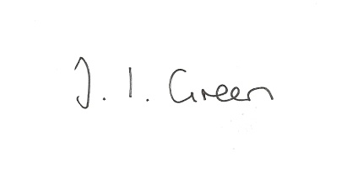

Joanna Green, clerk of the council 4/8/15

AGENDA

**Welcome**

**Public Session**

**73/16 Apologies**

**74/16 To receive Declarations of Interest**.

**75/16 To adopt the minutes of the meeting held on 12th July 2016 as a true record**

**76/16 To receive the clerk's report on matters being progressed from previous meetings.**

Gravel Pit field land registration

Western Parishes Liaison meeting

**77/16 Bus Services Consultation**

Correspondence from East Yorkshire Motor Services

To consider what action, if any, the Parish Council might take

**78/16 To review the council's budget for the year**

**79/16 Accounts**

The bank balance £ 3666.51

To approve the payments below:

Clerk's salary and allowance June £146.14

Yapham Parish Hall Fund £60.00

**80/16 Correspondence**

Humberside Police August bulletin

ERNLLCA Newsletter July

ERYC re Hull 2017 UK City of Culture - East Riding Programme

ERYC re funding: Places of worship security

Greggs Foundation - Local Community Projects Fund

HLF - Resilient Heritage

ERYC re resurfacing of A1079

ERYC re Local Offer ( families Information Service Hub)

NHS re prescribing over the counter drugs

NALC Community Led Housing Survey

**81/16 Councillors reports**

**82/16 Date of next meeting**