Yapham cum Meltonby Parish Council

[www.yaphamcummeltonby.co.uk](http://www.yaphamcummeltonby.co.uk)

Clerk : Mrs Jo Green, 29 Barmby Road, Pocklington, York YO42 2DL Tel.01759 301386

Dear Councillor

A meeting of Yapham cum Meltonby Parish Council will be held on **Tuesday 9th February 2016** in the **Village Hall, Yapham at 7.30pm**. You are summoned to attend, if you are unable to attend, please contact me in order that I can record your apologies.

Members of the public are welcome to attend the meeting and may address the council during the Public Participation period. An agenda for the meeting is shown below.

Yours sincerely,

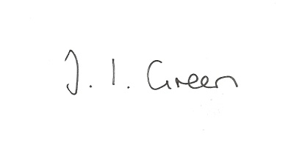Joanna Green, clerk of the council. 4/2/2016

AGENDA

**Welcome**

**Public Session**

**10/16 Apologies.**

**11/16 To receive Declarations of Interest.**

**12/16 To adopt the minutes of meetings held on 12th January 2016 as a true record**

**13/16 To receive the clerk's report on matters being progressed from previous meetings.**

Planning matters - Greenfield. Feoffee Lane

Neighbourhood Watch

Dog Fouling in Yapham

**14/16 Planning**

To receive notice of refusal of

|  |  |
| --- | --- |
| Proposal: | Retention of log cabin for use as dwelling, a domestic outbuilding, storage sheds and the erection of 3 polytunnels with associated infrastructure and building to house biomass boiler/fuel store |
| Location: | Eastfield Feoffee Common Lane Barmby Moor East Riding Of Yorkshire YO42 1PG |
| Applicant: | MacMagnus Ltd |

**15/16 Accounts**

Bank balance £2047.02

To approve the payments below:

Clerk's salary £113.57

Information Commissioner £35.00

**16/16 Correspondence**

Frack Free East Yorkshire re meetings Pocklington 9th Feb, Market Weighton 15th Feb.

East Riding Parish News -January & February

Humberside Police Bulletin - February

Tour de Yorkshire - 29,30 April,1 May

ERYC - funding for work on the A1079

NHS Vale of York Clinical Commissioning Group (CCG) - Governing body meeting 4 February

Forward Planning re Barmby Moor Neighbourhood development area

**17/16 Councillors reports**

including Cllr Bradley re Rural Partnership Strategy meeting and Cllr Moverley re Wolds Weighton Liaison Group.

**18/16 Date of next meeting**