**Yapham cum Meltonby Parish Council**

[www.yaphamcummeltonby.co.uk](http://www.yaphamcummeltonby.co.uk)

Clerk : Mrs Jo Green, 29 Barmby Road, Pocklington, York YO42 2DL Tel.01759 301386

Dear Councillor

A meeting of Yapham cum Meltonby Parish Council will be held on **Tuesday 10th January 2017** in the **Village Hall, Yapham at 7.30pm**. You are summoned to attend, if you are unable to attend, would you please contact me in order that I can record your apologies.

Members of the public are welcome to attend the meeting and may address the council during the Public Participation period.

Yours sincerely,

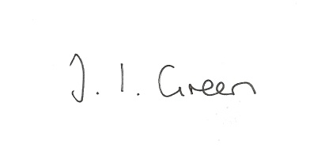

Joanna Green, clerk of the council 5/01/17

AGENDA

**1/17 Welcome & Apologies**

**2/17 To receive Declarations of Interest**.

**3/17 To resolve that the meeting is temporarily suspended to allow for a period of Public Participation**

**4/17 To adopt the minutes of the meeting held on 13th December 2016 as a true record**

**5/17 To receive the clerk's report on matters being progressed from previous meetings.**

Salt supplies

**6/17 To consider how the council can improve communications with residents**

**7/17 Accounts**

The bank balance £ 3033.19

To approve the payments below:

Clerk's salary and allowance December £134.01

Autela group - payroll services £28.91

**8/17 Correspondence**

Humberside Police Bulletin January

ERYC Neighbourhood Planning winter newsletter

ERYC East Riding Local Plan – Notice of adoption of the Open Space Supplementary Planning Document (November 2016)

ERNLLCA December newsletter

ERNLLCA re Royal Garden Parties

**9/17 Councillors reports**

**10/17 Date of next meeting**