**Yapham cum Meltonby Parish Council**

[www.yaphamcummeltonby.co.uk](http://www.yaphamcummeltonby.co.uk)

Clerk : Mrs Jo Green, 29 Barmby Road, Pocklington, York YO42 2DL Tel.01759 301386

Dear Councillor

A meeting of Yapham cum Meltonby Parish Council will be held on **Tuesday 10th October 2017** in the **Village Hall, Yapham at 7.30pm**. You are summoned to attend, if you are unable to attend, would you please contact me in order that I can record your apologies.

Members of the public are welcome to attend the meeting and may address the council during the Public Participation period.

Yours sincerely,

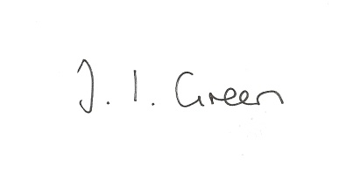

Joanna Green, clerk of the council 5/10/17

AGENDA

**103/17 Welcome & Apologies**

**104/17 To receive Declarations of Interest**.

**105/17 To resolve that the meeting is temporarily suspended to allow for a period of Public Participation**

**106/17 To adopt the minutes of the meeting held on 12th September 2017 as a true record**

**107/17 To receive the clerk's report on matters being progressed from previous meetings.**

Allotment Trees

Bus Stop

**108/17 Planning**

**To consider whether or not to support the application below:**

Proposal: 17/03157/PLF Construction of 2 all-weather turn out areas and lunge pen

Location: Equestrian Manege Fangfoss Road Yapham Mill East Riding Of Yorkshire

YO42 1PB

Applicant: Mr Charlie Bond

Application type: Full Planning Permission

**109/17 Accounts**

The bank balance £4274.36

To approve the payments below:

Clerk's salary and allowance September £135.10

HMRC £1.60

Yapham Parish Hall hire July-Sept £ 60.00

Autela Payroll Services July-Sept £33.60

**110/17 Correspondence**

ERYC - Beverley Literature Festival

Aldborough Parish Council - planning

Countryside Alliance - Rural Oscars

Library Theatre - touring plays

Friends of the Earth - Freedom of information request re Hydrocarbon exploration

ERYC - Safeguarding Adults Board Newsletter

ERYC - Urgent Care Services

ERYC - Pharmaceutical Needs Assessment Consultation

ERNLLCA newsletter

ERNLLCA - District Committee meeting 18 Oct , Sutton on Derwent Village Hall 7.30pm

Humberside Police October newsletter

ERYC - Community Safety Partnership survey

**111/17 Councillors reports**

**112/17 Date of next meeting**