**Yapham cum Meltonby Parish Council**

[www.yaphamcummeltonby.co.uk](http://www.yaphamcummeltonby.co.uk)

Clerk : Mrs Jo Green, 29 Barmby Road, Pocklington, York YO42 2DL Tel.01759 301386

Dear Councillor

A meeting of Yapham cum Meltonby Parish Council will be held on **Tuesday 11th April 2017** in the **Village Hall, Yapham at 7.30pm**. You are summoned to attend, if you are unable to attend, would you please contact me in order that I can record your apologies.

Members of the public are welcome to attend the meeting and may address the council during the Public Participation period.

Yours sincerely,

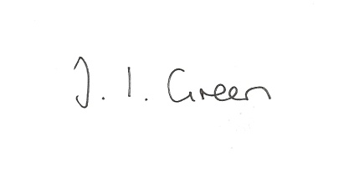

Joanna Green, clerk of the council 6/4/17

AGENDA

**34/17 Welcome & Apologies**

**35/17 To receive Declarations of Interest**.

**36/17 To resolve that the meeting is temporarily suspended to allow for a period of Public Participation**

**37/17 To adopt the minutes of the meeting held on 14th March 2017 as a true record**

**38/17 To receive the clerk's report on matters being progressed from previous meetings.**

Rural Policing

**39/17 Planning**

To receive notice of approval of:

17/0041/VAR Proposal: Variation of Condition 1 (15/03969/VAR) - External surface material details

Location: Land East Of 7 High Bields Yapham East Riding Of Yorkshire YO42 1PL

Applicant: Mr David Medley Application type: Variation of Condition(s)

To receive notice of dismissal of planning appeals relating to siting of a caravan at Alder Lodge, Feoffee Lane

**40/17 Accounts**

To consider the arrangements for audit of accounts

The bank balance £2468.07

To approve the payments below:

Clerk's salary and allowance March £134.01

Yapham Parish Hall Fund £60.00

**41/17 Correspondence**

ERYC invitation to planning liaison meetings

Wolds Heritage Trust - fracking presentation Thur 18 May 7.30-9.30pm Market Weighton Community Hall

ERYC - information from Community Transport launch

Pocklington Town Council - invitation to meeting with representative of East Yorkshire Motor Services

Pocklington In Need Charity - Race Night 7th April

ERNLLCA newsletter

ERNLLCA district committee 19 April at Middleton Village Hall

Humberside Police newsletter

**42/17 Councillors reports**

**43/17 Date of next meeting**