**Yapham cum Meltonby Parish Council**

[www.yaphamcummeltonby.co.uk](http://www.yaphamcummeltonby.co.uk)

Clerk : Mrs Jo Green, 29 Barmby Road, Pocklington, York YO42 2DL Tel.01759 301386

Dear Councillor

A meeting of Yapham cum Meltonby Parish Council will be held on **Tuesday 11th July 2017** in the **Village Hall, Yapham at 7.30pm**. You are summoned to attend, if you are unable to attend, would you please contact me in order that I can record your apologies.

Members of the public are welcome to attend the meeting and may address the council during the Public Participation period.

Yours sincerely,

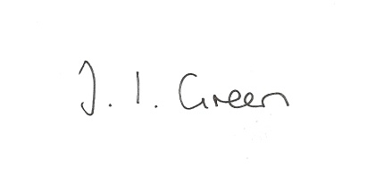

Joanna Green, clerk of the council 6/7/17

AGENDA

**71/17 Welcome & Apologies**

**72/17 To receive Declarations of Interest**.

**73/17 To resolve that the meeting is temporarily suspended to allow for a period of Public Participation**

**74/17 To adopt the minutes of the meeting held on 6th June 2017 as a true record**

**75/17 To receive the clerk's report on matters being progressed from previous meetings.**

Allotments

Planning enforcement

Village Taskforce Walkabout

**76/17 To consider replacing the seat in Yapham**

**77/17 To consider a request for a contribution towards the cost of cutting the grass in the churchyard.**

**78/17 To consider what action the Parish Council can take regarding Fly tipping and litter**

**79/17 Accounts**

The bank balance £4675.95

To approve the payments below:

Clerk's salary and allowance June £135.10

Clerk's expenses £ 39.54

Autela payroll services £ 33.60

HMRC £ 1.60

**80/17 Correspondence**

ERYC - Community Emergency Plans and Neighbourhood watch Groups

Humberside Police - Blue Light Showcase event

NHS - Changing the Future of GP Services event

ERYC - Lower Derwent Supplementary Planning document consultation

Dove House Hospice- Open Gardens

Friends of the Earth - Freedom of Information request

Humberside Police Bulletin

Cardiac Safe National campaign

NALC consultation re public sector pay

Road Closure Order Meltonby

ERNLLCA resolutions for AGM

ERYC - English Garden Future Fund

Humber and Wolds Rural Community Council - Invitation to join

Western Parishes Liaison Group - meeting Thur 27 July 7.00pm at Market Weighton Community Centre

Yorkshire Local Councils Association- day seminar in conjunction with Playscheme on Thursday 27 July (9.30am to 3.15pm) at Wheldrake Village Hall

**81/17 Councillors reports**

**82/17 Date of next meeting**