**Yapham cum Meltonby Parish Council**

[www.yaphamcummeltonby.co.uk](http://www.yaphamcummeltonby.co.uk)

Clerk : Mrs Jo Green, 29 Barmby Road, Pocklington, York YO42 2DL Tel.01759 301386

Dear Councillor

A meeting of Yapham cum Meltonby Parish Council will be held on **Tuesday 12th December 2017** in the **Village Hall, Yapham at 7.30pm**. You are summoned to attend, if you are unable to attend, would you please contact me in order that I can record your apologies.

Members of the public are welcome to attend the meeting and may address the council during the Public Participation period.

Yours sincerely,

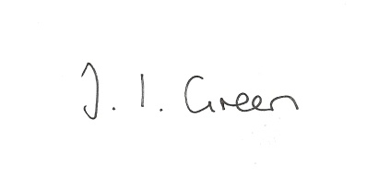

Joanna Green, clerk of the council 7/12/17

AGENDA

**123/17 Welcome & Apologies**

**124/17 To receive Declarations of Interest**.

**125/17 To resolve that the meeting is temporarily suspended to allow for a period of Public Participation**

**126/17 To adopt the minutes of the meeting held on 14th November 2017 as a true record**

**127/17 To receive the clerk's report on matters being progressed from previous meetings.**

Allotment Trees

Planning - retirement village Feoffee Common Lane

**128/17 Insurance- to consider insurance arrangements for the coming year.**

**129/17 Precept - to consider the budget and set the precept for 2018/19**

**130/17 Accounts**

The bank balance £

To approve the payments below:

Clerk's salary and allowance November £135.10

SLCC - membership £29.87

Autela Payroll services £

**131/17 Correspondence**

ERYC - Name Banks for new developments- reminder

ERNLLCA - newsletter

Humberside Police newsletter

ERYC-Outcome from Secretary of State for Health re Urgent Care Services

National Churches Trust - grants

ERYC - Chairman's awards

Smaller Authorities Audit Appointments - appointments for 17/18

Aldborough Parish Council - invitation to meeting about planning 18th January

ERYC - mobile library timetable

ERYC - Village Taskforce/Walkabout Satisfaction Survey

**132/17 Councillors reports**

**133/17 Date of next meeting**