**Yapham cum Meltonby Parish Council**

[www.yaphamcummeltonby.co.uk](http://www.yaphamcummeltonby.co.uk)

Clerk : Mrs Jo Green, 29 Barmby Road, Pocklington, York YO42 2DL Tel.01759 301386

Dear Councillor

A meeting of Yapham cum Meltonby Parish Council will be held on **Tuesday 12th September 2017** in the **Village Hall, Yapham at 7.30pm**. You are summoned to attend, if you are unable to attend, would you please contact me in order that I can record your apologies.

Members of the public are welcome to attend the meeting and may address the council during the Public Participation period.

Yours sincerely,

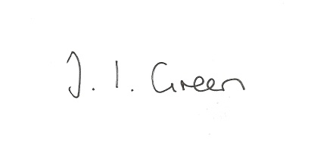

Joanna Green, clerk of the council 7/9/17

AGENDA

**93/17 Welcome & Apologies**

**94/17 To receive Declarations of Interest**.

**95/17 To resolve that the meeting is temporarily suspended to allow for a period of Public Participation**

**96/17 To adopt the minutes of the meeting held on 8th August 2017 as a true record**

**97/17 To receive the clerk's report on matters being progressed from previous meetings.**

Allotments

**98/17 Planning**

**To consider whether or not to support the applications below:**

Proposal: 17/02737/VAR Variation of condition 2 (number of pitches) of 14/00576/PLF to site no more than 7 Timber Camping Pods, 5 Touring Caravans, 3 Motorhomes and 10 Tents

Location: Yapham Holds Farmhouse Campsite Feoffee Lane Yapham East Riding Of

Yorkshire YO42 2PF

Applicant: Mr Stephen Hughes Application type: Variation of Condition(s)

Proposal: 17/02748/PLF Erection of a general purpose agricultural building

Location: Meltonby Grange Meltonby Road Meltonby East Riding Of Yorkshire YO42 1PW

Applicant: Mr & Mrs K Frank

Application type: Full Planning Permission

**99/17 Accounts**

The bank balance £4469.66

To approve the payments below:

Clerk's salary and allowance August £135.30

Yapham Parish Hall hire £ 60.00

**100/17 Correspondence**

ERYC- Code of Conduct training

NALC - citizenship survey

Rural Partnership - Annual review

Humberside Police Bulletin

Joint Access Forum - meeting 13 Sept 2.00pm The Courtyard, Goole

Clerk & Councils Direct

ERNLLCA - AGM papers for 14th September

**101/17 Councillors reports**

**102/17 Date of next meeting**