**Yapham cum Meltonby Parish Council**

[www.yaphamcummeltonby.co.uk](http://www.yaphamcummeltonby.co.uk)

Clerk : Mrs Jo Green, 29 Barmby Road, Pocklington, York YO42 2DL Tel.01759 301386

Dear Councillor

A meeting of Yapham cum Meltonby Parish Council will be held on **Tuesday 14th February 2017** in the **Village Hall, Yapham at 7.30pm**. You are summoned to attend, if you are unable to attend, would you please contact me in order that I can record your apologies.

Members of the public are welcome to attend the meeting and may address the council during the Public Participation period.

Yours sincerely,

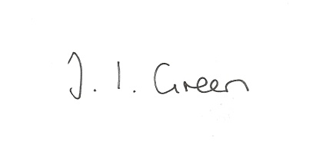

Joanna Green, clerk of the council 9/2/17

AGENDA

**11/17 Welcome & Apologies**

**12/17 To receive Declarations of Interest**.

**13/17 To resolve that the meeting is temporarily suspended to allow for a period of Public Participation**

**14/17 To adopt the minutes of the meeting held on 10th January 2017 as a true record**

**15/17 To receive the clerk's report on matters being progressed from previous meetings.**

Salt supplies

Methods of communication with residents

**16/17 To consider Community Bulk Buying Schemes for fuel etc.**

**17/17 Cllr Arnold to report on IT capability in the Village Hall**

**18/17 Planning**

To resolve whether or not to support the application below:

17/00106/STPLF

**Proposal:** Pocklington Flood Alleviation Scheme (PFAS) comprises of 1) Construction of a

flood attenuation bund (5m high, 600m in length and 45m wide with a 5.0m wide access/maintenance strip) across Pocklington Beck upstream of Pocklington; 2)a culvert to run through the attenuation bund with a flow control device which would maintain the flow of Pocklington Beck and associated access tracks and fencing

**Location:** Land East Of Fairview The Mile Pocklington East Riding Of Yorkshire

**Applicant:** East Riding Of Yorkshire Council

**Application type:** Strategic - Full Planning Permission

**19/17 To update the Emergency Plan**

**20/17 Accounts**

The bank balance £ 2810.27

To approve the payments below:

Clerk's salary and allowance January £134.01

Information Commissioner £35.00

**21/17 Correspondence**

ERYC - various messages during the inclement weather

ERYC - consultation on a Statement of Community Involvement

ERYC - consultation on Community Infrastructure Levy

ERYC - re Postcode Local Trust funding

ERYC - re local listing for next City of Culture brochure

ERYC - Overview & Scrutiny Committee response to Urgent Care Services

ERNLLCA - January newsletter

Humberside Police Bulletin

Mrs Barnes re parking at Yapham Mill and potholes.

ERYC - road closure notice

**22/17 Councillors reports**

**23/17 Date of next meeting**