**Yapham cum Meltonby Parish Council**

[www.yaphamcummeltonby.co.uk](http://www.yaphamcummeltonby.co.uk)

Clerk : Mrs Jo Green, 29 Barmby Road, Pocklington, York YO42 2DL Tel.01759 301386

Dear Councillor

A meeting of Yapham cum Meltonby Parish Council will be held on **Tuesday 14th March 2017** in the **Village Hall, Yapham at 7.30pm**. You are summoned to attend, if you are unable to attend, would you please contact me in order that I can record your apologies.

Members of the public are welcome to attend the meeting and may address the council during the Public Participation period.

Yours sincerely,

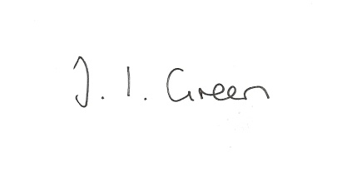

Joanna Green, clerk of the council 9/3/17

AGENDA

**24/17 Welcome & Apologies**

**25/17 To receive Declarations of Interest**.

**26/17 To resolve that the meeting is temporarily suspended to allow for a period of Public Participation**

**27/17 To adopt the minutes of the meeting held on 14th February 2017 as a true record**

**28/17 To receive the clerk's report on matters being progressed from previous meetings.**

Planning enforcement

Parking at Yapham Mill

Rural Policing

**29/17 Planning**

To resolve whether or not to support the application below:

17/0041/VAR Proposal: Variation of Condition 1 (15/03969/VAR) - External surface material details

Location: Land East Of 7 High Bields Yapham East Riding Of Yorkshire YO42 1PL

Applicant: Mr David Medley

Application type: Variation of Condition(s)

**30/17 Accounts**

The bank balance £ 2641.26

To approve the payments below:

Clerk's salary and allowance January £134.01

Clerk's expenses £10.27

**31/17 Correspondence**

ERYC - Growing a greener future grants

Humberside Police newsletter

ERYC - event listing on Hull City of Culture website

ERYC - Community Transport Strategy launch

ERYC - Local plan newsletter

Western Parishes Liaison Group - next meeting 27 April at Sancton Village Hall

Clerk & Councils Direct

ERYC- changes to planning publicity

ERNLLCA - newsletter

ERYC - Village Taskforce Walkabout 23 June 9.30am at the Village Hall

**32/17 Councillors reports**

**33/17 Date of next meeting**