**Yapham cum Meltonby Parish Council**

[www.yaphamcummeltonby.co.uk](http://www.yaphamcummeltonby.co.uk)

Clerk : Mrs Jo Green, 29 Barmby Road, Pocklington, York YO42 2DL Tel.01759 301386

Dear Councillor

A meeting of Yapham cum Meltonby Parish Council will be held on **Tuesday 6th June 2017** in the **Village Hall, Yapham at 7.30pm**. You are summoned to attend, if you are unable to attend, would you please contact me in order that I can record your apologies.

Members of the public are welcome to attend the meeting and may address the council during the Public Participation period.

Yours sincerely,

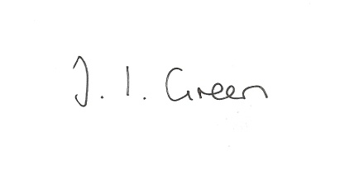

Joanna Green, clerk of the council 1/6/17

AGENDA

**59/17 Welcome & Apologies**

**60/17 To receive Declarations of Interest**.

**61/17 To resolve that the meeting is temporarily suspended to allow for a period of Public Participation**

**62/17 To adopt the minutes of the meeting held on 9th May 2017 as a true record**

**63/17 To receive the clerk's report on matters being progressed from previous meetings.**

Allotments

Annual return

**64/17 To consider the request for support from Full Sutton and Skirpenbeck Parish Coucil regarding the planning application for a new prison.**

**65/17 Planning**

To receive notification of permission granted:

17/01104/PLF Proposal: Erection of two storey extension to rear

Location: 4 The Square Yapham East Riding Of Yorkshire YO42 1PJ

Applicant: Mrs C Simpson Application type: Full Planning Permission

**66/17 To consider the renewal of the website domain name**

**67/17 Accounts**

The bank balance £4812.54

To approve the payments below:

Clerk's salary and allowance May £136.59

**68/17 Correspondence**

ERYC - Trusthouse Charitable Foundation , Skipton Building Society Grassroots Giving Fund, M & S Community Energy Fund.

ERYC - Cottingham Neighbourhood Development Plan

National Association of Local Councils (NALC) Survey

NALC note re Transparency Funding

ERNLLCA -"Battles Over"

ERNLLCA- Active Spaces Programme

ERNLLCA - newsletter

Humberside Police June bulletin

Seafarers UK - request to fly the red Ensign for Merchant Navy Day

Healthwatch- offer to attend coffee mornings, etc

**69/17 Councillors reports**

**70/17 Date of next meeting**