**Yapham cum Meltonby Parish Council**

[www.yaphamcummeltonby.co.uk](http://www.yaphamcummeltonby.co.uk)

Clerk : Mrs Jo Green, 29 Barmby Road, Pocklington, York YO42 2DL Tel.01759 301386

Dear Councillor

A meeting of Yapham cum Meltonby Parish Council will be held on **Tuesday 8th August 2017** in the **Village Hall, Yapham at 7.30pm**. You are summoned to attend, if you are unable to attend, would you please contact me in order that I can record your apologies.

Members of the public are welcome to attend the meeting and may address the council during the Public Participation period.

Yours sincerely,

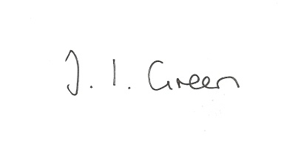

Joanna Green, clerk of the council 3/8/17

AGENDA

**83/17 Welcome & Apologies**

**84/17 To receive Declarations of Interest**.

**85/17 To resolve that the meeting is temporarily suspended to allow for a period of Public Participation**

**86/17 To adopt the minutes of the meeting held on 11th July 2017 as a true record**

**87/17 To receive the clerk's report on matters being progressed from previous meetings.**

Allotments

Planning enforcement

**88/17 Planning**

To receive notice of approval of:

Proposal: 17/01494/STOUT Outline - Erection of prison complex with associated perimeter fencing, access, parking, landscaping and infrastructure (access and scale to be considered)

Location: Land To The West Of HM Prison Full Sutton Moor Lane Full Sutton

East Riding Of Yorkshire YO41 1PS For: Ministry of Justice

**89/17 Accounts**

To receive the external auditor's report.

The bank balance £4604.76

To approve the payments below:

Clerk's salary and allowance July £135.10

**90/17 Correspondence**

Enquiry via website regarding Burnby

ERYC - East Riding Crime Reduction Fund

HWRCC - Community Led Housing

ERNLLCA July newsletter

Letter of Thanks from Rev Jan Hardy.

Humberside Police Bulletin

**91/17 Councillors reports**

**92/17 Date of next meeting**