**Yapham cum Meltonby Parish Council**

[www.yaphamcummeltonby.co.uk](http://www.yaphamcummeltonby.co.uk)

Clerk : Mrs Jo Green, 29 Barmby Road, Pocklington, York YO42 2DL Tel.01759 301386

Dear Councillor

A meeting of Yapham cum Meltonby Parish Council will be held on **Tuesday 10th April 2018** in the **Village Hall, Yapham at 7.30pm**. You are summoned to attend, if you are unable to attend, would you please contact me in order that I can record your apologies.

Members of the public are welcome to attend the meeting and may address the council during the Public Participation period.

Yours sincerely,

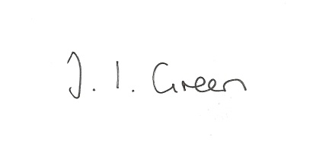

Joanna Green, clerk of the council 5/4/18

AGENDA

**34/18 Welcome & Apologies**

**35/18 To receive Declarations of Interest**.

**36/18 To resolve that the meeting is temporarily suspended to allow for a period of Public Participation**

**37/18 To adopt the minutes of the meeting held on 13th March 2017 as a true record**

**38/18 To receive the clerk's report on matters being progressed from previous meetings.**

General Data Protection Regulation

Allotments

**39/18 Planning**

**To consider whether or not to support the proposals below:**

Proposal 18/00808/PLF: Erection of two storey and first floor extensions to side and rear including

rendering and replacement of existing roof tiles with grey tiles, removal of side

access gate and erection of boundary wall

Location: Pond Yard Yapham Road Yapham Mill East Riding Of Yorkshire YO42 1PB

Applicant: Miss M Titley Application type: Full Planning Permission

**40/18 Accounts**

**To Consider whether the council is exempt from external audit for 2017/18**

The bank balance £2969.55

To approve the payments below:

Clerk's salary and allowance February £135.10

HMRC PAYE £1.60

ERNLLCA subscription £213.76

Autela Group Ltd £40.32

**41/18 Correspondence**

ERYC Community Led Housing Seminars - Driffield 12 April 6.00pm

ERYC Parish Transport Champions meetings

ERYC - invitation to Parish Council Liaison meetings

East Riding Safe-guarding adults newsletter

ERYC - communications survey

NALC - survey re ethical standards in local government

Residents request for a map of Yapham Mill to be placed on the notice-board.

NHS - Urgent Treatment Services

My Community Alert

**42/18 Councillors reports**

**43/18 Date of next meeting**