**Yapham cum Meltonby Parish Council**

[www.yaphamcummeltonby.co.uk](http://www.yaphamcummeltonby.co.uk)

Clerk : Mrs Jo Green, 29 Barmby Road, Pocklington, York YO42 2DL Tel.01759 301386

Dear Councillor

A meeting of Yapham cum Meltonby Parish Council will be held on **Tuesday 10th July 2018** in the **Village Hall, Yapham at 7.30pm**. You are summoned to attend, if you are unable to attend, would you please contact me in order that I can record your apologies.

Members of the public are welcome to attend the meeting and may address the council during the Public Participation period.

Yours sincerely,

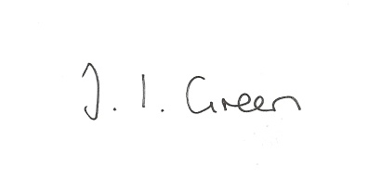

Joanna Green, clerk of the council 5/7/18

AGENDA

**70/18 Welcome & Apologies**

**71/18 To receive Declarations of Interest**.

**72/18 To resolve that the meeting is temporarily suspended to allow for a period of Public Participation**

**73/18 To adopt the minutes of the meeting held on 12th June 2018 as a true record**

**74/18 To receive the clerk's report on matters being progressed from previous meetings.**

Benches

Litter / Fly tipping

Blocked drain at end of Rowland Lodge lane

**75/18 Accounts**

The bank balance £ 4952.74

To approve the payment below:

Clerk's salary and allowance June £135.70

Autela Group Ltd - payroll services £46.80

Yapham Village Hall £60.00

**76/18 Correspondence**

Humberside Police -newsletter

ERYC - invitation to Wildlife Photographer of the Year exhibition

East Riding Safeguarding Adults Board - newsletter

ERYC safeguarding advice for community groups

Police and Crime Commissioner's Engagement Officer letter

ERNLLCA : important change to the law

Star Councils awards

AGM

District meeting

Remembrance Day Silhouette Grant Scheme

Clerks & Councils Direct

**77/18 Councillors reports**

**78/18 Date of next meeting**

**In view of the confidential nature of the business to be transacted the press and public will be asked to withdraw**.

**79/18 Appointment of new clerk**