**Yapham cum Meltonby Parish Council**

[www.yaphamcummeltonby.co.uk](http://www.yaphamcummeltonby.co.uk)

Clerk : Mrs Jo Green, 29 Barmby Road, Pocklington, York YO42 2DL Tel.01759 301386

Dear Councillor

A meeting of Yapham cum Meltonby Parish Council will be held on **Tuesday 12th June 2018** in the **Village Hall, Yapham at 7.30pm**. You are summoned to attend, if you are unable to attend, would you please contact me in order that I can record your apologies.

Members of the public are welcome to attend the meeting and may address the council during the Public Participation period.

Yours sincerely,

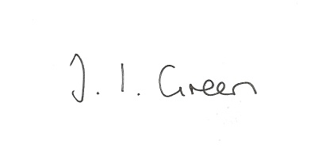

Joanna Green, clerk of the council 7/6/18

AGENDA

**59/18 Welcome & Apologies**

**60/18 To receive Declarations of Interest**.

**61/18 To resolve that the meeting is temporarily suspended to allow for a period of Public Participation**

**62/18 To adopt the minutes of the meeting held on 8th May 2018 as a true record**

**63/18 To receive the clerk's report on matters being progressed from previous meetings.**

Litter Bins

Allotment trees inspection

Meltonby speed limit

**64/18 Planning**

**To receive notice of approval of:**

Proposal: Erection of two storey and first floor extensions to side and rear including

rendering and replacement of existing roof tiles with grey tiles, removal of

side access gate and erection of boundary wall

Location: Pond Yard Yapham Road Yapham Mill East Riding Of Yorkshire YO42

1PB Applicant: Miss M Titley

**To receive notice of refusal of:**

Proposal18/360/PLF: Extension to existing livestock building and erection of new livestock

building (Re-submission of 16/03812/PLF)

Location: Wold View Farm Main Street Bolton East Riding Of Yorkshire YO41 5QS

Applicant: H. S. Thirsk & Son

**65/18 To agree arrangements for recruitment of clerk.**

**66/18 Accounts**

The bank balance £5088.44

To approve the payment below:

Clerk's salary and allowance May £135.70

**67/18 Correspondence**

ERNLLCA May newsletter

Public Spaces Protection Order consultation 2019

Joint Local Access Forum AGM 13 June 2.00pm Burnby Hall

Letter of thanks from Rev Jan Hardy

ERNLLCA CIL survey

Clicktrans - request for website link

ERYC - Permission in Principle Process

**68/18 Councillors reports**

**69/18 Date of next meeting**