**Yapham cum Meltonby Parish Council**

[www.yaphamcummeltonby.co.uk](http://www.yaphamcummeltonby.co.uk)

Clerk : Mrs Jo Green, 29 Barmby Road, Pocklington, York YO42 2DL Tel.01759 301386

Dear Councillor

A meeting of Yapham cum Meltonby Parish Council will be held on **Tuesday 13th February 2018** in the **Village Hall, Yapham at 7.30pm**. You are summoned to attend, if you are unable to attend, would you please contact me in order that I can record your apologies.

Members of the public are welcome to attend the meeting and may address the council during the Public Participation period.

Yours sincerely,

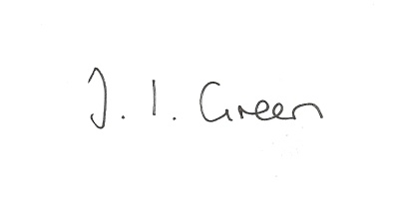

Joanna Green, clerk of the council 08/2/18

AGENDA

**12/18 Welcome & Apologies**

**13/18 To receive Declarations of Interest**.

**14/18 To resolve that the meeting is temporarily suspended to allow for a period of Public Participation**

**15/18 To adopt the minutes of the meeting held on 9th January 2017 as a true record**

**16/18 To receive the clerk's report on matters being progressed from previous meetings.**

Allotment Trees

First Aid training

**17/18 To consider the draft risk assessment**

**18/18 To consider the impact of the General Data Protection Regulation on the Parish Council**

**19/18 Accounts**

The bank balance £3347.60

To approve the payments below:

Clerk's salary and allowance January £135.30

G Woodward - reimburse postage £12.65

Yapham Parish Hall - hire £60.00

Information Commissioner £35.00

**20/18 Correspondence**

Humberside Police Bulletin

Information Commissioner - newsletter including General Data Protection Regulation(GDPR)

Autela - changes due to GDPR

Library Theatre - events July - Dec 2018

Aldborough Parish Council - notes on meeting about planning

ERYC- invitation to rural housing seminar 1st March 9.30am to 12.45pm

**21/18 Councillors reports**

**22/18 Date of next meeting**