**Yapham cum Meltonby Parish Council**

[www.yaphamcummeltonby.co.uk](http://www.yaphamcummeltonby.co.uk)

Clerk : Mrs Jo Green, 29 Barmby Road, Pocklington, York YO42 2DL Tel.01759 301386

Dear Councillor

A meeting of Yapham cum Meltonby Parish Council will be held on **Tuesday 13th March 2018** in the **Village Hall, Yapham at 7.30pm**. You are summoned to attend, if you are unable to attend, would you please contact me in order that I can record your apologies.

Members of the public are welcome to attend the meeting and may address the council during the Public Participation period.

Yours sincerely,

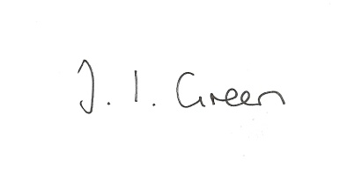

Joanna Green, clerk of the council 08/3/18

AGENDA

**23/18 Welcome & Apologies**

**24/18 To receive Declarations of Interest**.

**25/18 To resolve that the meeting is temporarily suspended to allow for a period of Public Participation**

**26/18 To adopt the minutes of the meeting held on 13th February 2017 as a true record**

**27/18 To receive the clerk's report on matters being progressed from previous meetings.**

First Aid training

Risk Assessment

General Data Protection Regulation

**28/18 Allotment rent review**

**29/18 Planning**

**To consider whether or not to support the proposals below:**

Proposal 18/00274/PLF : Construction of dormer windows and roof lights to front and rear following loft conversion and pitched roof over existing garage

Location: Hillcrest Main Street Yapham East Riding Of Yorkshire YO42 1PH

Applicant: Mr A Chappel-Ross Application type: Full Planning Permission

Proposal 18/00360/PLF: Extension to existing livestock building and erection of new livestock building (Re-submission of 16/03812/PLF)

Location: Wold View Farm Main Street Bolton East Riding Of Yorkshire YO41 5QS

Applicant: H. S. Thirsk & Son Application type: Full Planning Permission

Proposal18/00478/PLF: Alterations and extensions including erection of two storey extension to front following demolition existing porch and installation of rooflights

Location: Northfield House Meltonby Road Meltonby East Riding Of Yorkshire YO42 1TW

Applicant: Mr Michael Ragg Application type: Full Planning Permission

**30/18 Accounts**

The bank balance £3104.65

To approve the payments below:

Clerk's salary and allowance February £135.10

**31/18 Correspondence**

Humberside Police Bulletin

ERYC Emergency Planning - severe weather updates

Local Council Public Advisory Service - Review of ethical standards in local government

**32/18 Councillors reports**

**33/18 Date of next meeting**