**Yapham cum Meltonby Parish Council**

[www.yaphamcummeltonby.co.uk](http://www.yaphamcummeltonby.co.uk)

Clerk : Mrs Jo Green, 29 Barmby Road, Pocklington, York YO42 2DL Tel.01759 301386

Dear Councillor

A meeting of Yapham cum Meltonby Parish Council will be held on **Tuesday 14th August 2018** in the **Village Hall, Yapham at 7.30pm**. You are summoned to attend, if you are unable to attend, would you please contact me in order that I can record your apologies.

Members of the public are welcome to attend the meeting and may address the council during the Public Participation period.

Yours sincerely,

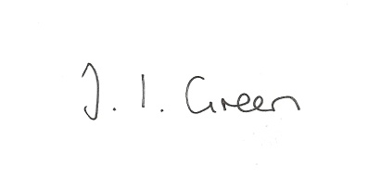

Joanna Green, clerk of the council 9/8/18

AGENDA

**80/18 Welcome & Apologies**

**81/18 To receive Declarations of Interest**.

**82/18 To resolve that the meeting is temporarily suspended to allow for a period of Public Participation**

**83/18 To adopt the minutes of the meeting held on 10th July 2018 as a true record**

**84/18 To receive the clerk's report on matters being progressed from previous meetings.**

Benches

Litter / Fly tipping

**85/18 Planning**

To consider whether or not to support the proposals below:

**Proposal:** 18/01814/PLF Erection of a single storey building for use as office / staff room following removal of portacabin, erection of a portal framed building for the storage of hay and straw and erection of a stable block with tack room, wash room and feed store

**Location:** The Stables Fangfoss Road Yapham Mill East Riding Of Yorkshire YO42 1PB

**Applicant:** Mr Charles Bond **Application type:** Full Planning Permission

**Proposal:** 18/02486/PLF Erection of a grain store

**Location:** Treveen House Meltonby Lane Yapham East Riding Of Yorkshire YO42 1PN

**Applicant:** Mr Trevor Woodliffe **Application type:** Full Planning Permission

**86/18 Accounts**

The bank balance £ 4710.24

To approve the payment below:

Clerk's salary and allowance July £148.82

Clerk's expenses £ 19.74

**87/18 Correspondence**

Humberside Police -newsletter

Community Led Affordable Housing event at Wilberfoss on 22nd September

ERYC - Flood and Coastal Risk Survey

R Thomas - local history query

ERNLLCA - Consultation re future of adult social care

ERNLLCA - newsletter

**88/18 Councillors reports**

**89/18 Date of next meeting**