Yapham cum Meltonby Parish Council

[www.yaphamcummeltonby.co.uk](http://www.yaphamcummeltonby.co.uk)

Clerk : Mrs Jo Green, 29 Barmby Road, Pocklington, York YO42 2DL Tel.01759 301386

Dear Councillor

A meeting of Yapham cum Meltonby Parish Council will be held on **Tuesday 8th May 2017** in the **Village Hall, Yapham at 7.30pm**. You are summoned to attend, if you are unable to attend, would you please contact me in order that I can record your apologies.

Members of the public are welcome to attend the meeting and may address the council during the Public Participation period. An agenda for the meeting is shown below.

Yours sincerely,

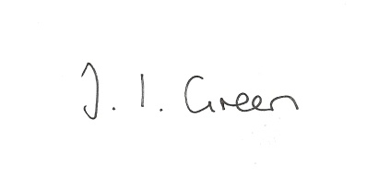

Joanna Green, clerk of the council. 3/5/18

AGENDA

**44/18 Welcome and Apologies**

**45/18 To elect officers:**

Chairman

Vice- Chairman

Representatives to other bodies

**46/18 To approve the Annual Governance Statement for 2017/18**

**47/18 to approve the accounts for 2017/18**

**48/18 to approve financial arrangements for the coming year :**

To approve the Financial Standing Orders

To appoint an internal auditor

To appoint bank signatories.

**49/18 To receive Declarations of Interest**.

**50/18 To adopt the minutes of the meeting held on 10th April 2018 as a true record**

**51/18 To receive the clerk's report on matters being progressed from previous meetings.**

Meltonby Planning conditions

**52/18 Planning**

To receive revised information regarding:

Construction of dormer windows and roof lights to front and rear following loft

conversion and pitched roof over existing garage at Hillcrest, Main Street, Yapham, East

Riding Of Yorkshire, YO42 1PH, for Mr A Chappel-Ross - Application type: Full

Planning Permission

To receive notice of approval of:

Proposal 18/00478/PLF: Alterations and extensions including erection of two storey extension to

front following demolition existing porch and installation of rooflights

Location: Northfield House Meltonby Road Meltonby East Riding Of Yorkshire

YO42 1TW Applicant: Mr Michael Ragg

**53/18 Data Protection**

**To adopt data protection policy and procedures**

**To consider appointment of a Data Protection Officer**

**54/18 To consider the clerk's rate of pay**

**55/18 Accounts**

The bank balance £5224.14

To approve the payments below:

Clerk's salary April £135.70

**56/18 Correspondence**

Humberside Police newsletter

ERYC Rural Partnership - Rural Crime Survey

ERYC - Antisocial Behaviour Statistics

Hull University - open campus talks

ERYC Rural Housing Seminar

ERYC Joint Minerals Plan consultation

ERYC - changes to EYMS bus services

postofficesnearme - request for website link

ERNLLCA - rural crime survey

**57/18 Councillors reports**

**58/18 Date of next meeting**