**Yapham cum Meltonby Parish Council**

[www.yaphamcummeltonby.co.uk](http://www.yaphamcummeltonby.co.uk)

Clerk : Mrs Jo Green, 29 Barmby Road, Pocklington, York YO42 2DL Tel.01759 301386

Dear Councillor

A meeting of Yapham cum Meltonby Parish Council will be held on **Tuesday 9th January 2018** in the **Village Hall, Yapham at 7.30pm**. You are summoned to attend, if you are unable to attend, would you please contact me in order that I can record your apologies.

Members of the public are welcome to attend the meeting and may address the council during the Public Participation period.

Yours sincerely,

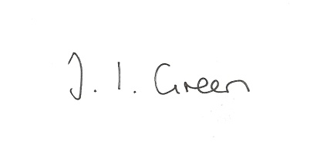

Joanna Green, clerk of the council 4/1/18

AGENDA

**1/18 Welcome & Apologies**

**2/18 To receive Declarations of Interest**.

**3/18 To resolve that the meeting is temporarily suspended to allow for a period of Public Participation**

**4/18 To adopt the minutes of the meeting held on 12th December 2017 as a true record**

**5/18 To receive the clerk's report on matters being progressed from previous meetings.**

Allotment Trees

First Aid training

**6/18 Precept - to consider the budget and set the precept for 2018/19**

**7/18 Planning**

to receive notice of refusal of planning for :

Proposal 17/03398/OUT: Outline - Erection of a dwelling (All Matters Reserved)

Location: Land South East Of Ferndene Feoffee Common Lane Barmby Moor East

Riding Of Yorkshire YO42 1PG Applicant: Mr David And Mrs Vivien Wright

**8/18 Accounts**

The bank balance £3618.10

To approve the payments below:

Clerk's salary and allowance December £135.10

Autela Payroll services £33.60

Mark Feather tree report £100.00

HMRC £1.80

**9/18 Correspondence**

ERYC forward planning-Consultation on the East Riding Local Plan Draft Sustainability Appraisal Scoping Report

VHEY - East Yorkshire Remarkable Tourism Awards

ERYC emergency planning - Northern Powergrid Vulnerable People and Communities

Gaye Woodward - old documents

**10/18 Councillors reports**

**11/18 Date of next meeting**