Yapham cum Meltonby Parish Council

[www.yaphamcummeltonby.co.uk](http://www.yaphamcummeltonby.co.uk)

Clerk : Mrs Jo Green, 29 Barmby Road, Pocklington, York YO42 2DL

Tel.01759 301386

Dear Councillor

A meeting of Yapham cum Meltonby Parish Council will be held on **Tueday 14th October 2014** in the **Village Hall, Yapham at 7.30pm**. You are summoned to attend, if you are unable to attend, would you please contact me in order that I can record your apologies.

Members of the public are welcome to attend the meeting and may address the council during the Public Participation period.

An agenda for the meeting is shown below.

Yours sincerely

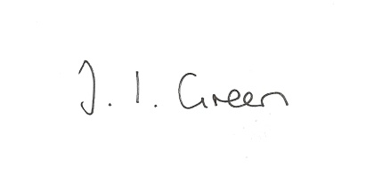

Joanna Green, clerk of the council.

4/10/14

AGENDA

**Public Session.**

**Welcome and Apologies**.

**164/14 Declaration of Interest. The Parish Councils Code of Conduct. To record any declarations of interest by any member in respect of items on this agenda.**

**165/14 To adopt the minutes of meetings held on 9 Sept 2014 and 17 Sept 2014 as a true record**

**166/14 To receive the clerk's report on matters being progressed from previous meetings.**

Website

ERNLLCA Training

Community Partnership meeting

**167/14 To Resolve to support, or otherwise, the planning applications below.**

**Application number: 14/02416/PLF**

Erection of an agricultural building

Land North East and North West of Yapham Cricket Club

Applicant: Miss Hazel Coulson

Full Planning Permission

**Application Number: 12/04703/PLF**

Amended Plans for stable managers dwelling

Land North West of Yapham Grange, Yapham Mill

Applicant: Mr Charles Bond

Full Planning Permission

**Application Number: 14/02857/PLF**

Erection of a dwelling

Land North East of 7 High Bields, Yapham

Applicant: Mr David Medley

Full Planning Permission

**168/14 To receive notice of approval with conditions of variations to application no: 13/04177/PLF**

**169/14 Accounts: to approve payments of the following**

clerk's salary September £83.64

HMRC months 4-6 £62.40

Yapham Parish Hall £80.00

**170/14 Correspondence**

Town and Parish Councils event 9th October

Rural Partnership Conference on the future of the Yorkshire Wolds 16th October

Hull City Council re Independent Commission of Inquiry

ERYC re Boundary Referendum

ERYC press release re reorganisation of Humberside Police

ERNLLCA District Committee meeting 15th October

Code of Conduct Training for councillors and clerks - various dates inc. Pocklington 28th October

Letter regarding annual audit

**171/14 Councillors reports**

**172/14 Date of Next Meeting**