Yapham cum Meltonby Parish Council

[www.yaphamcummeltonby.co.uk](http://www.yaphamcummeltonby.co.uk)

Clerk : Mrs Jo Green, 29 Barmby Road, Pocklington, York YO42 2DL

Tel.01759 301386

Dear Councillor

A meeting of Yapham cum Meltonby Parish Council will be held on **Tuesday 4th November 2014** in the **Village Hall, Yapham at 7.30pm**. You are summoned to attend, if you are unable to attend, would you please contact me in order that I can record your apologies.

Members of the public are welcome to attend the meeting and may address the council during the Public Participation period. An agenda for the meeting is shown below.

Yours sincerely,

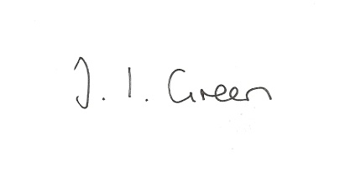

Joanna Green, clerk of the council. 27/10/14

AGENDA

**Public Session.**

**Welcome and Apologies**.

**173/14 Declaration of Interest. The Parish Councils Code of Conduct. To record any declarations of interest by any member in respect of items on this agenda.**

**174/14 To adopt the minutes of meeting held on 14 October 2014 as a true record**

**175/14 To receive the clerk's report on matters being progressed from previous meetings.**

Website

**176/14 To finalise details of the Local Grant Fund regarding snow clearing equipment.**

**177/14 To receive notice of approval with conditions for planning application 14/02548/PLF for a porch and extension of Embege Feoffee Lane.**

**178/14 Accounts: to approve payments of the following**

Autela Ltd for payroll services £14.85

HC Slingsby plc for Hi-Vis Vests £24.98

Mscomputers Ltd ( via Clerk) for head torches £24.80

**179/14 Correspondence**

Pocklington Local Links Network Forum Wed 12th November 6-8pm

Broadband East Riding update

East Riding Crime and Community Safety Survey

ERYC Rough sleepers estimate 2014

East Riding Safeguarding Adults re training

**180/14 Councillors reports**

**181/14 Date of Next Meeting**