Yapham cum Meltonby Parish Council

[www.yaphamcummeltonby.co.uk](http://www.yaphamcummeltonby.co.uk)

Clerk : Mrs Jo Green, 29 Barmby Road, Pocklington, York YO42 2DL

Tel.01759 301386

Dear Councillor

A meeting of Yapham cum Meltonby Parish Council will be held on **Tuesday 9th December 2014** in the **Village Hall, Yapham at 7.30pm**. You are summoned to attend, if you are unable to attend, would you please contact me in order that I can record your apologies.

Members of the public are welcome to attend the meeting and may address the council during the Public Participation period. An agenda for the meeting is shown below.

Yours sincerely,

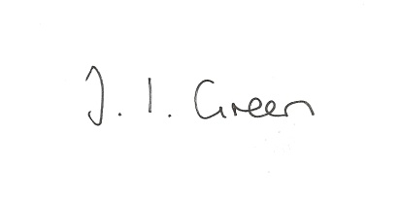

Joanna Green, clerk of the council. 1/12/14

AGENDA

**Public Session.**

**186/14 Welcome and Apologies**.

**187/14 Declaration of Interest. The Parish Councils Code of Conduct. To record any declarations of interest by any member in respect of items on this agenda.**

**188/14 To adopt the minutes of meetings held on 4th November and 18th November 2014 as a true record**

**189/14 To receive the clerk's report on matters being progressed from previous meetings.**

Website

Overflowing ditch opposite village hall

Enforcement issues

Yapham Mill village sign

**190/14 To consider making a contribution towards the clerk's membership of the Society of Local Council Clerks**

**191/14 To set the precept for 2015/16**

**192/14 Accounts**

Zurich Municipal - insurance £243.80

J Green clerk's salary November £126.54

J Ackerley - newsletter £5.00

**193/14 Correspondence**

ERYC re traveller and gypsy encampments

ERYC Chairman's awards

ERYC re Lifeline Telecare Service

East Riding Parish News November

Community Partnership re defibrillators

North Ferriby - East YorkshireVillagers at War

ERNLLCA Newsletter

**194/14 Councillors' reports**

**195/14 To receive Cllr Ackerley's resignation and appoint another bank signatory.**

**196/14 Date of Next meeting and meeting start times.**