Yapham cum Meltonby Parish Council

[www.yaphamcummeltonby.co.uk](http://www.yaphamcummeltonby.co.uk)

Clerk : Mrs Jo Green, 29 Barmby Road, Pocklington, York YO42 2DL

Tel.01759 301386

Dear Councillor

A meeting of Yapham cum Meltonby Parish Council will be held on **Tuesday 18th November 2014** in the **Village Hall, Yapham at 6.00pm**. You are summoned to attend, if you are unable to attend, would you please contact me in order that I can record your apologies.

Members of the public are welcome to attend the meeting and may address the council during the Public Participation period. An agenda for the meeting is shown below.

Yours sincerely,

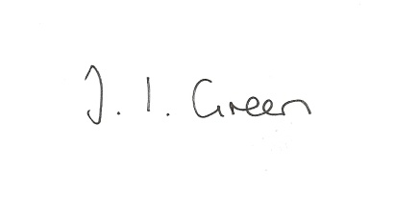

Joanna Green, clerk of the council. 13/11/14

AGENDA

**Public Session.**

**182/14 Welcome and Apologies**.

**183/14 Declaration of Interest. The Parish Councils Code of Conduct. To record any declarations of interest by any member in respect of items on this agenda.**

**184/14 To Resolve to support, or otherwise, the planning applications below.**

Application No. 14/02416/PLF

Erection of an agricultural building for storage of farm machinery and animal feeds and retention of animal shelter (amended plans)

Land North East and North West of Yapham Cricket Club Feoffee Lane Yapham

Applicant : Miss Hazel Coulson

Full Planning Permission

**185/14 To receive notice of approval with conditions of variations to application no:12/04703/PLF**

Erection of a Stable Managers dwelling at Yapham Mill.