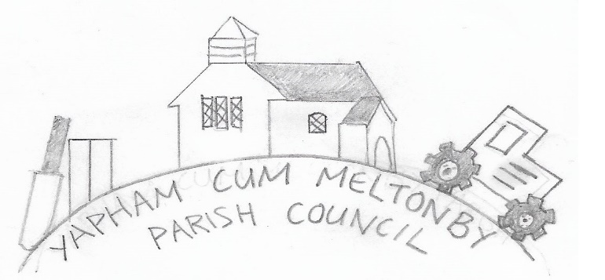

[www.yaphamcummeltonby.co.uk](http://www.yaphamcummeltonby.co.uk)

Clerk: Sadie Rothwell-Inch, [YCMclerk@mail.com](mailto:YCMclerk@mail.com), YO42 4LT Tel: 01759 319122

Minutes of Meeting of Yapham cum Meltonby Parish Council on **Tuesday 8th October 2019** in

Yapham Village Hall at 7.30pm

**Present:** Cllr Arnold, Cllr Bradley (chair), Cllr Hammond, Cllr Jefferson-Hallett, Cllr Moverley, S. Rothwell-Inch (clerk).

**130/19 Welcome and Apologies:** Cllrs Gray and Newman sent apologies. Cllr Bradley opened the meeting and welcomed everybody present.

**131/19 To receive Declarations of Interest:**  none

**132/19 To resolve that the meeting is temporarily suspended to allow for a period of Public Participation:**  none

**133/19 To adopt the minutes of the meeting held on 10th September 2019 as a true record:** Proposed by Cllr Moverley and seconded by Cllr Hammond

**134/19 To receive the clerk's report on matters being progressed from previous meetings:**  The clerk attempted to make progress with the VAT rebate enquiry and was told it is a busy time and matter are in hand.

**135/19 Planning:** No applications received

**136/19 To consider the contents of the asset register for Insurance purposes:** Agreed – the contents were reviewed and the register updated, to reflect deletions and additions, in time for the insurance renewal in January 2020

**137/19 To consider works carried out by ERYC in response to the Parish Walkabout event:** Agreed – the majority of major highways works are complete; potholes filled along with road signage and markings being refreshed.

**138/19 To consider wildlife in the parish:** Agreed - defer to next meeting

**139/19 Accounts**

The bank balance - £4,196.74

The payments below were approved:

Rental for village hall from April to September £120.00

Clerk's salary for September (inc tax rebate) £171.63

Autela (payroll services) £47.08

Cllr Moverley (repair equipment) £16.78

**140/19 To note correspondence:** noted

**141/19 Councillors reports:**

**Cllr HAMMOND –** requested the logo, designed as this year’s competition winner, be present on all further parish council correspondence and information.

**The next** Western Parishes Liaison meeting will be held on Wednesday 22nd January 2020 in Bishop Wilton Hall.

**Full Sutton Prison –** spoke against the proposed development with one other councillor but the motion was passed with eight votes to four. Currently only outline panning is granted with the condition of no building to exceed a height of 16 metres. The Ministry of Justice will submit full plans in due course. Cllr Hammond has also, with the help of another ward councillor, consulted Greg Knight for advice about any additional infrastructure.

**Feoffee Lane telegraph poles -** East Riding Council has now launched an investigation into the installation of poles allegedly without prior planning permission. There are instances where this is not required for vital services but it is unsure whether this instance falls under that category.

**Neighbourhood Watch –** councillors expressed their disappointment at the lack of public attendance at the meeting about the community crime-prevention initiative despite recent criminal activity in the area. Cllr Hammond delivered letters to each household in the parish and hopes the Crime Stoppers card he included, complete with telephone number to report any suspicious behaviour or offense, will suffice.

**Town and Parish Council review panel report –** attended a training course and gleaned essential information about the powers of parish councils. Documented information will be circulated to all councillors.

**Cllr MOVERLEY –** Agreed. Cllr Moverley repairs and reinstates the fallen noticeboard in its original position of Yapham Square, and cost of materials reimbursed.

**Cllr BRADLEY -** led the councillors in wishing Cllr Hammond well for his upcoming three-month internship at Westminster. They look forward to his return to parish meetings in early 2020.

**142/19 Date of next meeting:** Tuesday 12th November 2019

Meeting closed at 8.50pm

|  |  |
| --- | --- |
|  |  |
|  |  |