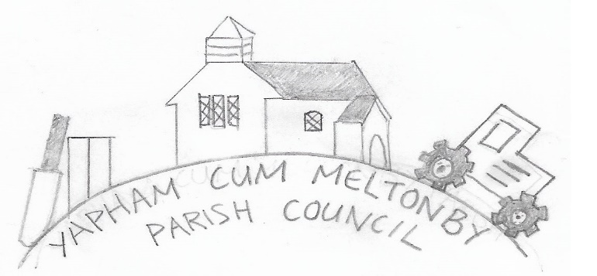

Yapham cum Meltonby Parish Council

[www.yaphamcummeltonby.co.uk](http://www.yaphamcummeltonby.co.uk)

Clerk: Sadie Rothwell-Inch, Neann Croft, Seaton Ross, YORK, YO42 4LT Tel: 01759 319122

Minutes of Meeting of Yapham cum Meltonby Parish Council on **Tuesday 12th November 2019** in

Yapham Village Hall at 7.30pm

**Present:** Cllr Arnold, Cllr Bradley (chair), Cllr Gray, Cllr Hammond, Cllr Jefferson-Hallett, Cllr Moverley, S. Rothwell-Inch (clerk).

**143/19 Welcome and Apologies:** Cllr Bradley opened the meeting and welcomed everybody present.

**144/19 To receive Declarations of Interest:** Cllr Gray declared a non-pecuniary interest in the flooding drains at Rowland Lodge.

**145/19 To resolve that the meeting is temporarily suspended to allow for a period of Public Participation:**  none present.

**1146/19 To adopt the minutes of the meeting held on 8th October 2019 as a true record:** Signed byCllr Bradley**.** Proposed by Cllr Moverley. Seconded by Cllr Arnold.

**147/19 To receive the clerk's report on matters being progressed from previous meetings:** All bank procedures have been dealt with including a telephone appointment to update HSBC for security aspects. HSBC wishes to ensure the correspondence details for the clerk are valid. Online banking for the parish is now in place and the clerk is awaiting an authentication code to trigger implementation. Correspondence between the PC and ERYC planning department revealed that the poles on Feoffe Lane are not in breach of any planning rules. The asset register is now updated and insurance quotes are being gathered for 2019/20. A letter has been sent to HMRC requesting a refund for overpaid tax by the clerk.

**148/19 To consider the following planning applications:**

19/03432/PLF: Construction of two-lane cricket net | Yapham Cricket Club Feoffee Lane Yapham East Riding of Yorkshire YO42 1PE | Application type: Full planning permission**: Agreed** – Planning comment submitted thus: At a meeting held on Tuesday 12th November 2019 Yapham Parish Council agreed to support this proposal in principal but raised concerns that the nets will take up space currently used for parking cars and would like to refer the matter to committee. There is currently a minor on-street parking issue which the council would not like to see exacerbated. YCM council believes there might be potential for relocation of the proposed nets to an area within the grounds, further from the entrance and not currently used for parking.

19/03628/PLF | Erection of a single storey building to provide garage/trailer store/games room/gym and garden store following demolition of existing stables:  Mr & Mrs Wilcock | Westfield Farm Feoffee Lane Yapham East Riding of Yorkshire YO42 1PF | Application type: Full planning permission. **Agreed** – No issues with this application.

**Notice of approval was received for:** 19/02803/PLF | Erection of a single storey building for use as office/staff room/reception following removal of portacabin (retrospective), erection of a portal framed building for the storage of hay, straw and stable waste and erection of a stable block with tack room, wash room and feed store | (Resubmission of 18/01814/PLF) | Status: Application granted subject to outlined conditions: Noted.

**149/19 To finalise the contents of the asset register for Insurance purposes and consider Insurance costs 2020/21:** Asset register approved.The clerk is currently gathering insurance quotes.

**150/19 To consider the Positive Activity Grant 2019/20:** Ongoing – Potential projects were discussed. Cllr Hammond will look into community funding and ways to improve local facilities.

**151/19 To consider wildlife in the parish:** Ongoing – Cllr discussed ways to preserve wildlife in the parish. Agreed to reflect and bring any ideas to the next meeting.

**152/19To consider the flooding outside Rowland Lodge and effects on the main highway:** There is water flooding out of the drain and pooling at the bottom of the property where the drive meets the main road between Stamford Bridge and Pocklngton. A new site visit is being planned by ERYC. Cllrs Hammond and Gray have insisted on attending the meeting as they believe the situation is hazardous.

**153/19 Village Hall Events:** Cllrs thanked Cllr Jefferson-Hallett for her Halloween night efforts. It was also noted that a recent performance from musical group, La Bella was enjoyed by all who attended.

**154/19 Telephone Box – Agreed:** Door requires repair and painting is also needed. Cllr Hammond will acquire the necessary estimates.

**155/19 Accounts:** The bank balance – £3888.33

Clerk’s salary was paid.

**156/19 To note correspondence:** Noted

**157/19 Councillors reports: Cllr Moverley –** expressed concerns about an increase in heavy goods vehicles driving through Feoffee Lane, despite there being no designated passing places, and would like to examine the possibility of signage to deter such traffic.

**Cllr Arnold –** confirmed that the commemorative plaque is now in place on the Yapham bench.

**158/19 Date of next meeting –** Tuesday 10th December 2019

**Meeting closed at 8.50pm**

|  |  |
| --- | --- |
|  |  |