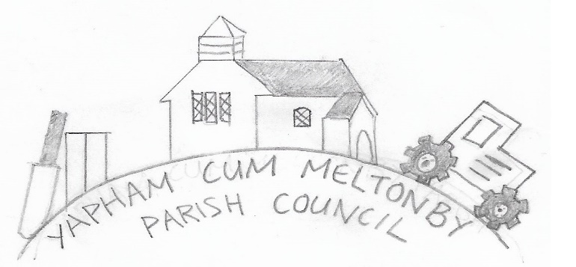

Yapham cum Meltonby Parish Council

[www.yaphamcummeltonby.co.uk](http://www.yaphamcummeltonby.co.uk)

Clerk: Sadie Rothwell-Inch - Tel: 01759 318122

Minutes of Meeting of Yapham cum Meltonby Parish Council on **Tuesday 10th December 2019** in

Yapham Village Hall at 7.30pm

**Present:** Cllr Arnold, Cllr Bradley (chair), Cllr Gray, Cllr Hammond, Cllr Moverley, Cllr Newman, S. Rothwell-Inch (clerk).

**159/19 Welcome and Apologies:** Cllr Jefferson-Hallett sent her apologies. Cllr Bradley welcomed everyone present.

**160/19 To receive Declarations of Interest:** Cllr Gray declared a non-pecuniary interest in Rowland Lodge.

**161/19 To resolve that the meeting is temporarily suspended to allow for a period of Public Participation:** none.

**162/19 To adopt the minutes of the meeting held on 12th November 2019 as a true record:** Proposed by Cllr Newman and seconded by Cllr Gray.

**163/19 To receive the clerk's report on matters being progressed from previous meetings:** The online banking facility is now in place. Measures have been taken to facilitate HSBC in their generic security upgrade, and confirmation that all is robust should be received by the clerk prior to 27th January 2020.

**164/19 To consider the possibility of new road signs in Feoffe Lane to deter heavy goods vehicles:**

**Agreed** – no further action at this time.

**165/19 To consider insurance costs 2020/21:** A number of quotes have been obtained by the clerk, all in excess of the renewal quote received from Came & Co. **Agreed –** Renew current policy at an annual cost of £218.00

**166/19 To consider the precept:**

**Agreed -** The precept will be raised by 3% in line with inflation.

**167/19To consider possible grants and projects: Agreed –** Future projects could include revamping the telephone box and bus shelter along with introducing dog waste bins to the parish. Cllrs would like to focus on creating some practical, helpful ad attractive community features.

**168/19 To discuss the lawnmower:**

**Agreed –** To be sold for £175.00

**169/19 To plan VE Day celebrations:**

**Agreed –** Planning a community event will be an integral part of the agenda up to April 2020. Celebrations are Friday 8th May 2020. Suggestions so far comprise a combined street party and village hall event with a wartime theme.

**170/19 To discuss village seat process for additional name plates: Agreed –** Plaques may be placed for any relative, who was born in or lived in the parish, killed in action during the second world war.

**171/19 Accounts:** The bank balance – £3,841.25

Clerk's salary for November was approved.

**172/19 To note correspondence:**  noted

**1173/19 Councillors reports:**

**Cllr Hammond and Cllr Gray** met with the Village Taskforce for a second site visit to the entrance to Rowland Lodge in order to address the drainage problems affecting the main road. They have yet to hear back from them. Action – Cllr Hammond will seek answers prior to our January PC meeting.

**Cllr Bradley** was delighted with the children’s Christmas card competition won by Wesley Jefferson-Hallett. She sent copies to friends and associates in various countries around the world to champion the involvement of children in the community and urging them to follow suit.

**158/19 Date of next meeting:** Tuesday 14th January 2020

|  |  |  |
| --- | --- | --- |
|  | |  |
|  | |  |
|  |  |