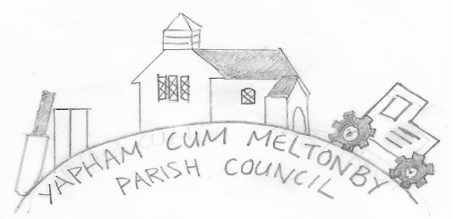

Yapham cum Meltonby Parish Council

[www.yaphamcummeltonby.co.uk](http://www.yaphamcummeltonby.co.uk)

Clerk: Sadie Rothwell-Inch - Tel: 01759 318122

Minutes of Meeting of Yapham cum Meltonby Parish Council on **Tuesday 11th February 2020** in

Yapham Village Hall at 7.30pm

**Present:** Cllr Arnold, Cllr Bradley (chair), Cllr Gray, Cllr Hammond (from 8.15pm), Cllr Moverley, S. Rothwell-Inch

**15/20** Apologies from Cllr Newman. Cllr Bradley welcomed everyone to the meeting

**16/20 To receive Declarations of Interest:**  none

**17/20 To resolve that the meeting is temporarily suspended to allow for a period of Public Participation:** none

**18/20 Minutes** of meeting held on 12th January 2020 as true record**:** Proposed, Cllr Moverley, Seconded by Cllr Gray.

**19/20 Clerk’s Report:** Banking issues have finally been resolved and we are able to make bill payments online. Problems with Autela invoices not being sent to the clerk, as RFO, have been addressed and resolved.

**20/20** Resubmission of planning application 19/40255/NONMAT (Non-Material Amendment to Planning Approval 14/02578/STPLF- minor changes to fenestration and construction of pond in a different location) for Park Farm **Agreed:** Clerk to write to Planning to request compliance assurance that tree-planting is in accordance with landscape plan. **(Action Clerk)**

**21/20 VE Day celebrations - Agreed:** Cancelled due to lack of public interest. Five people attended the meeting.

**22/20 Grass-cutting in Yapham churchyard – Agreed:** YCM council will finance one cut annually (currently £78.00)

**23/20 Dog waste in the parish - Agreed:** further investigation and action to be taken. Awareness must be raised about the growing problem. Clerk to find out if bins are a feasible option to begin **(Action Clerk)**

**24/20 Taskforce Village Walkabout 2020 – Agreed:** Final report noted. All issues complete or being done.

**25/20 Litter in the parish – Agreed:** Parish Litter-Picking Day on Sunday 5th April 2020 at 2-4pm. Equipment to be sourced from ERYC **(Action Clerk)**

**26/20 Yapham telephone box – Agreed:**  deferred until next meeting

**27/20 Accounts:** The bank balance – £3237.16

Following payments were approved: Clerk's salary for January 2020 - £139.43

Clerk's salary for February 2020 - £139.43 (to pay online)

Autela Payroll Services Invoice – Dec 2019 -£47.08

Village Hall Invoice, Oct, Nov, Dec 2019 - £60.00 (to pay online)

Received and noted: Rebate from HMRC for tax overpaid - £32.20

**28/20 Correspondence:** noted

**29/20 Councillors reports: Cllr Hammond:** The telephone box door now works again.

**30/20 Date of next meeting:** Tuesday 12th March 2020

**Meeting closed: 9.10pm**