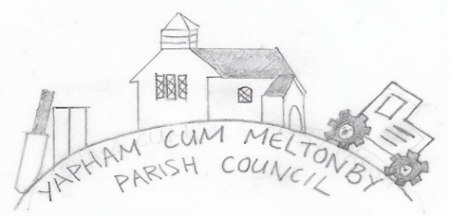

Yapham cum Meltonby Parish Council

[www.yaphamcummeltonby.co.uk](http://www.yaphamcummeltonby.co.uk)

Clerk: Sadie Rothwell-Inch - Tel: 01759 318122

Minutes of Meeting of Yapham cum Meltonby Parish Council on **Tuesday 10th March 2020** in

Yapham Village Hall at 7.30pm

**Present:** Cllr Arnold, Cllr Bradley (chair), Cllr Gray, Cllr Hammond, Cllr Jefferson-Hallett, Cllr Moverley, Cllr Newman, S. Rothwell-Inch (clerk)

**31/20** Cllr Bradley welcomed everyone to the meeting.

**32/20 To receive Declarations of Interest:**  none.

**33/20 To resolve that the meeting is temporarily suspended to allow for a period of Public Participation:** none.

**34/20 Minutes** from 11th February 2020 are true record**:** Proposed by Cllr Moverley, Seconded by Cllr Newman.

**35/20 To receive decision:** Variation of Condition 20 (Approved Plans) of planning permission16/00107/STPLF – **noted**.

**36/20 VE Day celebrations - Agreed:** Despite funding opportunity from ERYC – still insufficient interest in Parish.

**37/20 Grass-cutting in Yapham churchyard – Agreed:** email provided to clerk to facilitate payment of £78.00.

**38/20 Flower/bulb planting - Agreed:** Deferred until autumn for blooming in spring 2021

**39/20 Pollution - noted:** Complaints were received of large-scale rubbish-burning, creating toxic fumes and potential health hazards. ERYC have taken appropriate action to resolve the situation.

**40/20 Yapham telephone box – Agreed:**  Contact BT to reconnect electricity for a light **(Action Clerk)**

**41/20 Litter in the parish – Agreed:** Parish Litter-Picking Day on Sunday 5th April 2020 at 2-4pm. Equipment to be collected from ERYC in Market Weighton **(Action Cllr Hammond)**

**42/20 Accounts:** The bank balance – £2958.30

Following payment was approved: Clerk's salary for March 2020 - £139.43 (to pay online)

**Agreed:** Emma Fletcher to act as Internal Auditor again.

**Noted:** Fraudulent Activity - The clerk told how emails were intercepted and Village Hall Invoice, Oct, Nov, Dec 2019 for £60.00 was inadvertently paid to a recipient under the banking definition of ‘Authorised Push Payment Scam’. Payment was identified as fraudulent and repaid to the council bank account in three separate payments of £20.00.

**43/20 Correspondence:** noted

**44/20 Councillors reports: Cllr Hammond** has requested ERYC fill in potholes by Yapham Cricket Club and the 30mph sign on Meltonby Lane. ERYC will also pay a site visit to Yapham Mill to assess parking measures, close to the junction, to ensure road safety.

**Cllr Arnold** reminds everyone that tickets are still available for the Family Quiz Night on Saturday 28th March.

**Cllr Moverley** reportsthe worsening of potholes along Feoffe Lane.

**Cllr Gray** emphasised need for vigilance around vulnerable parish members in case of isolation re Corona Virus.

**45/20 Date of next meeting:** Tuesday 14th April 2020

**Meeting closed: 8.35pm**