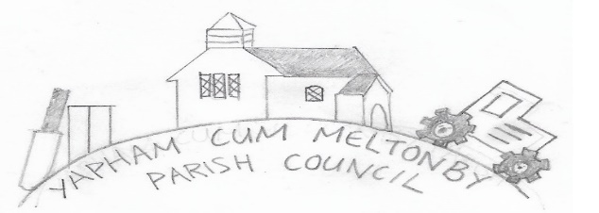

Yapham cum Meltonby Parish Council

[www.yaphamcummeltonby.co.uk](http://www.yaphamcummeltonby.co.uk)

Email: YCMClerk2@gmail.com

Clerk: Sadie Rothwell-Inch - Tel: 01759 318122 / 07810 260 702

Minutes of Meeting of Yapham cum Meltonby Parish Council on **Tuesday 11th August 2020** in

Yapham Village Hall at 7.30pm

**Present:** Cllr Arnold, Cllr Bradley (in the chair), Cllr Gray, Cllr Hammond, Cllr Jefferson-Hallett, Cllr Moverley, Cllr Newman, Sadie Rothwell-Inch (clerk)

**59/20** Cllr Bradley welcomed everyone and opened the meeting.

**60/20 To receive Declarations of Interest:** none.

**61/20 To resolve that the meeting is temporarily suspended to allow for a period of Public Participation:** No members of the pubic attended.

**62/20** The minutes of the meeting held on 14th July 2020 were approved as a true record. Proposed by Cllr Gray and seconded by Cllr Hammond

**63/20** The Annual Governance Statement for 2019/2020 was approved and signed by Cllr Bradley and the clerk

**64/20** The accounts for 2019/2020 were approved and signed by Cllr Bradley and the clerk.

**65/19** The financial arrangements for the coming year were approved:

The Financial Standing Orders were approved

The Internal Auditor remains as Emma Fletcher

The bank signatories remain unchanged

Projects and associated budgets are temporarily suspended in light of the Covid-19 crisis.

**66/20 Planning: Agreed -**  No objections. No concerns raised:20/02296/PLF / Erection of a first-floor extension to the rear and a single storey extension to the rear / 5 Woodbine Fold Yapham East Riding of Yorkshire YO42 1PR / Mr & Mrs S Edwards / **Application type:** Full Planning Permission

**67/20 The bin and flower planter at Meltonby:**

**Bin:** Cllr Hammond attended a site visit with ERYC and implementation is in progress.

Cost: £217.16 + VAT, £105.00 fitting cost (no VAT)

**Planters: Agreed –** ERYC have no record of an owner for the planters. They will be adopted by the Parish Council for use as a community project at a later date.

**68/20 The telephone box in Yapham:** Thanks were given to Cllr Moverley for installing bookshelves and generally tidying the interior. **Agreed:** Paint will be purchased for the exterior, most likely in the spring of 2021

**69/19 Communities framework & the devolution white paper: Agreed:** The councillors have sufficient understanding of the proposals.

**70/20 Accounts:** The bank balance – £4727.07

Approval was given for: payment of Clerk’s August salary

Payment of invoice for Internal Audit 2020 - £168.00

**71/20 Correspondence:**  noted.

**72/20 Councillors reports:**

**Cllr Hammond** stated that the roadworks, currently outside the village hall, are for essential drain works and a direct result of the Village Walkabout meetings with ERYC officials.

**Cllr Arnold** declared that The People’s Pantry in Pocklington will be grateful for any homegrown donations (or other) during the harvest season. This is in acknowledgement of an increase in allotment activity since the lockdown measures began. Donations can be made at the Rugby Club every Wednesday morning – thank you.

**73/20 Date of next meeting:** Tuesday 8th September 2020

**Meeting closed by Cllr Bradley at 8.30PM**

|  |  |
| --- | --- |
|  |  |