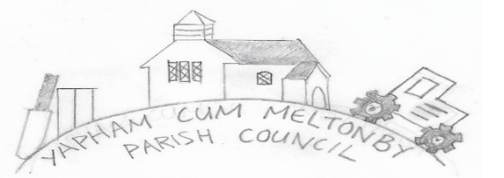

Yapham cum Meltonby Parish Council

[www.yaphamcummeltonby.co.uk](http://www.yaphamcummeltonby.co.uk)

Email: YCMClerk2@gmail.com

Clerk: Sadie Rothwell-Inch - Tel: 01759 318122 / 07810 260 702

Minutes of Meeting of Yapham cum Meltonby Parish Council on **Tuesday 8th September 2020** in

Yapham Village Hall at 7.30pm

**Present:** Cllr Arnold, Cllr Bradley (in the chair), Cllr Gray, Cllr Hammond, Cllr Moverley, Cllr Newman, Sadie Rothwell-Inch (clerk)

**74/20** Cllr Bradley welcomed everyone and opened the meeting. Apologies received from Cllr Jefferson-Hallett,

**75/20 To receive Declarations of Interest:** None

**76/20 To resolve that the meeting is temporarily suspended to allow for a period of Public Participation:**  Non present.

**77/20 To adopt the minutes of the meeting held on 11th August 2020 as a true record:** Agreed **–** Proposed by Cllr Gray and seconded by Cllr Newman.

**78/20 To consider the telephone box in Yapham:** Ongoing research.

**79/20 To consider a new bin at Yapham Mill:** Deferred – Await results of the next PC budget and determine feasibility.

**80/20 To consider the Keep Britain Tidy Campaign September 2020:** A parish litter-picking day has been set for Sunday 25th October 2020 from 2PM. (Action: Clerk to source ERYC equipment, Cllr Hammond to produce leaflets, Cllr Arnold to distribute emails).

**81/20 To consider ‘Personnel Committee’:** Resolved – Committee established as Cllr Arnold, Cllr Grey (chair) and Cllr Newman. Committee will meet a minimum of twice yearly to ensue effectiveness of clerk’s role and ensure any employment issues ae addressed.

**82/20 To discuss the planters at Meltonby:** Photographs need to be taken to ascertain position for ERYC Assets Department (Action Cllr Hammond & Clerk).

**83/20 To complete the ERYC Community Survey:** Completed and submitted at this meeting 8.24PM.

**84/20 To consider Joint Local Access Forum AGM from ERYC Democratic Services:** Agreed – submit the following question to the meeting of September 16th 2020, Agenda Item 3: ‘Is it possible for ERYC to suggest specific bus timetables and routes to allow for effective commuting and spending more time using public amenities?’.

**85/20 Planning Application:** 20/01892/PLF Westfield Farm Feoffee Lane YaphamAgreed **-** No objections.

**86/20 Accounts:** The following were approved:

Bank balance – £4439.64.

Clerk’s salary for September 2020

The Bank Reconciliation to September 2020.

**87/20 Correspondence:** noted.

**88/20 Councillors reports:** Cllr Hammond reported that the telegraph poles at the east end of Feoffee Lane, due to be removed during the bank holiday weekend road closure, were in fact replaced by new ones. He has made BT aware of the error and is negotiating a date for removal of the new poles.

**89/20 Date of next meeting:** Tuesday 13th October 2020.

**Meeting closed at 8.55PM.**