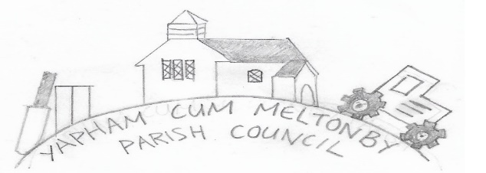

Yapham cum Meltonby Parish Council

[www.yaphamcummeltonby.co.uk](http://www.yaphamcummeltonby.co.uk)

Email: YCMClerk2@gmail.com

Clerk: Sadie Rothwell-Inch - Tel: 01759 318122 / 07810 260 702

UNADOPTED Minutes of Meeting of Yapham cum Meltonby Parish Council

on **Tuesday 13th October 2020** online at 7.15pm

**Present:** Cllr Arnold, Cllr Bradley (chair), Cllr Gray, Cllr Hammond, Cllr Jefferson-Hallett, Cllr Moverley, Cllr Newman, Sadie Rothwell-Inch (clerk)

**90/20** Cllr Bradley welcomed everyone and opened the meeting.

**91/20 To receive Declarations of Interest**: None.

**92/20 To resolve that the meeting is temporarily suspended to allow for a period of Public Participation**: None.

**93/20 To adopt the minutes of the meeting held on 8thth September 2020 as a true record**: Proposed by Cllr Moverley and seconded by Cllr Gray.

**94/20 To receive a report from the clerk about ongoing items:**

**AGM:** The clerk sought advice and there is no necessity to hold an AGM but all members were asked to visit their Declaration of Interests and declare any changes: **No changes made**.

**Planters:** at Meltonby junction: The planters appear to be within a Public Highway verge and therefore the Andrew Addison, the Highway Area Engineer for this area, will advise whether or not the parish can take on the responsibility of maintaining the planters*.* An application form will be submitted along with a copy of our liability insurance.

**YCM question to Joint Local Access Forum meeting:** - 16 September - reply to public question about bus timetables and facilitating travel in rural areas: Email response was forwarded to council: A link to a timetable was provided as an online journey planning tool.

**95/20 To consider altering the frequency and means of parish council meetings during the Covid-19 pandemic:**

Concerns were raised by some councillors that the second wave of Covid-19 pandemic implies face to face meetings carry greater risks than online versions thus YCM meetings should be conducted as such. While bearing this in mind it was noted that current government guidelines state a council can still meet face to face if it so wishes. It was also noted that reduced activity in the area means bi-monthly meetings are possible with the dual purpose of optimising clerk resources to address additional admin and legislative duties that currently fall outside of the allocated contractual hours.

**Resolved**: Bi-monthly meetings to be held and the situation reviewed at each meeting. Proposed: Cllr Moverley and Seconded: Cllr Arnold. **Agreed.**

**Resolved**: Meetings to be held online. Voted 5:2 with Cllr Hammond and Cllr Gray against due to current government advice stated above.

**96/20 Planning:** To receive Notification of Decision for App Ref 20/02296/PLF5 Woodbine Fold Yapham East Riding of Yorkshire YO42 1PR – Approved: **Noted.**

To receive Notification of Decision on App Ref 20/01892/PLF Westfield Farm Feoffee Lane Yapham East Riding of Yorkshire YO42 1PF – Approved: **Noted.**

To consider application**:** Planning Consultation for 20/02334/PLF /The Paddock Fangfoss Road Yapham Mill East Riding of Yorkshire YO42 1PB / Erection of a detached double garage – **Noted with no comments.**

**97/20 To consider the impact of the new Meltonby bin and feasibility of installing another in the parish:** The bin at Meltonby has been well-received and utilised appropriately. New bin to be placed beside the bench at Yapham Mill. Proposed: Cllr Hammond and Seconded: Cllr Bradley. AGREED. **Action** – Clerk to contact ERYC to arrange.

**98/20 Accounts:** The bank balance – £4460.21: **Noted**

The following payments were approved: Clerk’s salary for October 2020

Autela Payroll Invoice: 01/07/20 - 30/09/20, Jul, Aug, Sept £51.25

ERYC Invoice: 66064522 In respect of bin in Meltonby £452.59

To acknowledge receipt of payment from Gravel Pit Allotments £160.00: **Noted**.

**99/20 To note correspondence:** Noted.

**100/20 Councillors reports:**

**Cllrs Gray and Hammond:** Cllr Gray asked for a review of plans for a village gathering to collect litter, due to the rise in Covid-19 cases in the area. Cllr Hammond also requested a review of plans. RESOLVED: There will be no litter pick this autumn and plans will resume for another in spring 2021: AGREED.

**Cllr Hammond:** Delighted to announce that the telegraph poles on Feoffee Lane have finally been removed. During a walk through Meltonby Cllr Hammond noticed some sinkage in the road. ERYC have been informed and requested to fix it. This is ongoing.

**101/20 Date of next meeting:** December 8th 2020

Meeting closed at 8.20PM